**Application Information Document**

**ORMB Application**

Version 1.0

**Revision History**

|  |  |  |
| --- | --- | --- |
| **Version #** | **Description of Changes** | **Issue Date** |
| 1.0 | Initial version | 10/27/2016 |
|  |  |  |
|  |  |  |
|  |  |  |
|  |  |  |
|  |  |  |

**Document Control Section**

**Authors**

|  |  |
| --- | --- |
| **Role** | **Name** |
| Deloitte Consultant – LO | Arun Ganesan |
| Deloitte Consultant – LO | Rahul Singh |
|  |  |

**Reviewers**

|  |  |
| --- | --- |
| **Role** | **Name** |
|  |  |
|  |  |

**Transition Management Team Owner**

|  |  |
| --- | --- |
| **Role** | **Name** |
|  |  |
|  |  |

**Table of Contents**

1. Document OBJECTIVE 6

1.1 Document Information 6

2. Terminology and Acronyms 7

3. Application OVERVIEW 8

3.1 Applications Architecture Overview 10

3.2 Application Process 11

4. environment AND TOOLS DETAILS 14

4.1 Environments details: 14

4.2 Software/Tools: 15

4.3 Access: 16

4.4 Invoice Generation Process in Detail: 18

4.5 Reports Finalization and Generation Flow: 21

4.6 System Process Flow of Finalized/Pending Bills: 21

5. Application configuration setup 23

5.1 Customer/Group Setup 23

5.2 Pricing Setup 27

5.3 Reports Setup 29

5.4 Billing 30

5.5 Payments 31

6. ADJUSTMENTS 37

6.1 Refund 37

6.2 Write-Off 39

7. Transaction Feed Management 41

7.1 Functional Overview 41

7.2 Technical Overview 42

8. Stop loss functionality 49

8.1 Overview 49

8.2 Stop Loss Customer Setup 49

9. DISCOUNT ARRANGEMENTS 62

10. INTEREST CALCULATION 66

11. interfaces 71

11.1 EDI 820, 824/827 71

11.2 Commissions ISGB 74

11.3 LGCRS 75

11.4 EDWard 77

11.5 GL 78

11.6 DMS (AP) 80

11.7 Bill Print / Invoice Presentment 81

11.8 Refund EFT 83

12. BO Reports and Views: 86

12.1 RMB External Reports: 86

12.2 RMB Cash Ops Reports: 87

12.3 Internal Client Reports: 87

12.4 Accounting Reports: 88

13. Control M – ProD Batch Schedule 91

13.1 RMB batch monitoring (offshore): 91

13.2 Detailed Batch Jobs: 93

14. Reference Documents 94

# Document OBJECTIVE

The objective of the Application Information Document (AID) is to provide members of the delivery team with an overview of Anthem’s ORMB, business intelligence environment. The AID describes the function, structure, configuration and the technical environment of the application. This document refers to any existing related documentation.

The AID will be used in conjunction with the Application Support Control Plan (ASCP) to support the application. The delivery team will maintain the AID throughout the life of the ORMB application.

## Document Information

|  |  |
| --- | --- |
| AID Owner | Deloitte LO/POR team for ORMB Application |
| AID Intended Audience | Existing Lights On team; Anthem SME; New on boarding member of the team  **Document location:**  [link](https://wgsmodernization.atlassian.net/wiki/display/WET/ORMB+-+Deliverables) |

# Terminology and Acronyms

Acronyms and terminology specifically used in this document are described below.

| **Term, Acronym or Abbreviation** | **Description** |
| --- | --- |
| BTRD | Business Technical Requirement Document |
| HLD | High Level Design Document |
| Customer | Groups/Companies/Purchaser Organizations that pay premiums/receive healthcare services from the health-plan |
| ETL | Extract Transform and Load |
| FDD | Functional Design Document |
| FTP | File Transfer Protocol |
| IM | Information Management |
| INFA | ETL Tool – Informatica |
| LZ | Landing Zone |
| Member | Subscribers to the health-plan |
| SA | Staging Area |
| SDLC | System Development Life Cycle |
| SLA | Service Level Agreement |
| SQ | Service Quantity |
| UAT | User Acceptance Testing |
| UPI | Unique Provider ID |
| WGS | WellPoint Group Systems; an administrative source system for medical claims, membership, and revenue, primarily used for BCC and Unicare business. |
| WLM | Work Load Manager |
| WLP | WellPoint |
| WMR | WellPoint Metadata Repository |
| RMB | Revenue Management and Billing |
| ABS | Automated Billing System |
| AFBS | Alternately Funded Billing System |
| ASO | Administrative Services Only |
| BSD | Business Specifications Document |
| CDHP | Consumer Driven Health Plan |

# Application OVERVIEW

Oracle Revenue Management and Billing (**ORMB**) for Financial Services enhances the efficiency of the billing process offering a robust platform for calculating revenue and creating invoices for fee based services. The solution can optimize favorable customer pricing with what-if analysis for negotiating rates, which includes a billing calculation engine that generates information from processing systems like Automated Clearing house (ACH) and other modes of payment systems. The tool applies pricing methods and rules to create customer invoices as well as the associated financial transactions for general ledger. It provides open interfaces for accepting payment transactions from customers to create and inquire upon current customer balances. It supports flexible configuration of customer and product hierarchies to allow you to create invoices in accordance with your contract and pricing agreements.

The RMB system is the new end-to-end financial web-based tool to provide standardization and yet remains flexible in the following areas:

* Customer Information Management
* Pricing and Rating
* Billing
* Payment Collection
* Receivable Management
* Collections and Write-off
* Workflow Management

This initiative will implement an Oracle product called Revenue Management and Billing (RMB), which will replace the current 5 ASO Billing applications (AFBS, ABS, SIP, SIBS, and SMCR). RMB is an integrated solution which can perform Billing, Cash/AR, and Accounting.

The RMB platform will provide significant new business functionality as well as the ability to increase speed to market.

* Ability to adjust reimbursement amounts and sell additional financial arrangements including percent of discount, fee pass through and other cost sharing arrangements, new forms of stop-loss coverage, etc.
* Ability to provide customer self service capabilities
* Provide flexibility in billing schedules and bank options that HIX legislation will encourage
* Enables automation eliminating significant manual work

**Business Process Flow:**

* **Customer Setup** **–** This section describes the setup of new groups and the renewals of existing groups. It also includes how the customer information will be maintained along with the group hierarchy; billing entities and ORMB transactional contracts within ORMB.
* **Products, Pricing and Transactions Processing** **–** The Pricing and Transactions section describes the various transactions that come into ORMB, and how these are rated and consolidated into billable charges for invoicing purposes. This section also defines how pricing is defined and assigned to a group.
* **Billing –** The billing solution describes how invoices are produced for billing entities in ORMB. It also includes how invoices are actually produced.
* **Payments –** describe how incoming payments are processed within ORMB.
* **Accounting –** The section covers how journal entries are created and interfaced to the General Ledger.



**In scope:**

* All customers currently billed or managed by all ASO teams are within the Enterprise.
* The scope of this document is limited to provide details about ORMB BO design only and is depicted in the future section.

**Technical Implementation Overview:**

* Customer Setup entity is captured in the CISADM schema tables from the ORMB system.
* ‘Pricing and Transactions’ entity is performed by the Business Users from the ORMB interface which is captured in the Customer Setup table in CISADM Schema which is processed by RHUB.
* Core billing entity has Set of Daily frequency batch jobs which takes Inputs from RHUB landing Zone tables and process the data (Claims/Transactions) into RMB schema tables like CIS_TXN_HEADER and CI_TXN_DETAIL_STG. All this data would be validated for Business scenarios in multiple levels by different jobs and create an XML Invoice file which will be converted in to PDF & delivered for Business review.
* Payments Entity – End users review these Pending payments from the generated Invoices and finalize them which would again be processed by the ORMB batch jobs to generate finalized bills.
* Accounting – Daily Batch Jobs generates Journal Entries which are consumed by PeopleSoft GL. Also, Edward extract file is generated (Claims and Revenue Data) which is FTP to Edward server.
* Mainframe On-demand system (Interface to General Ledger) consumes these Invoice which are reviewed by the Business.

## Applications Architecture Overview

**ORMB *A*pplication Architecture:**

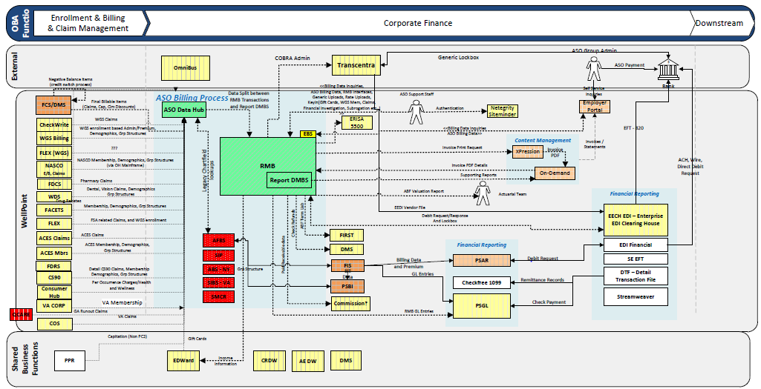

* Inbound transactions come into ORMB via a number of transaction feeds. The "HUB” will be responsible for mapping the transaction records from the various feeds directly into ORMB Transaction tables.
* Claims from Enrollment and Billing systems feed to Financial Claim System (FCS) which determines when claims should paid to Providers, Payment System, DMS and Hospitals….
* RHUB takes data files from FCS on to Informatica platform and load Claims to Landing Zone /Staging tables in RMB.
* Claims, PC2, Capitation, Item and Generic…. are the different types of Transactions feed to RMB.
* RMB reporting tables are populated by the Materialized View refresh job which acts as source for Business Objects Reports.
* On top of ORMB transaction tables a summary PDF invoice is generated which is FTP to On-demand system.
* BO generates the detail reports which also FTP to On-demand system.
* External reports, banking reports (EDI reports) are sent to Financial Reporting team.

## Application Process

**Logical Design Overview of System:**



* The source data sent by the inbound Interfaces will undergo required validations and transformations and loaded into RHUB Landing Zone tables.
* Landing zone tables, admin data will be transformed and loaded into Admin Staging and Claims data will be transformed and loaded into RMB.
* Admin data from Admin staging will be loaded into RMB. Reporting Repository will be loaded with data from RMB and landing zone tables.
* Outbound feeds will be generated with data from RMB and landing zone History tables in Reporting repository.

**Module Interaction Descriptions:**

|  |  |
| --- | --- |
| **Process** | **Description** |
| Data flow out of the Source system | * Source files from all source systems will be sent to the Informatica server on daily/weekly/monthly basis (or based on admin data request trigger) depending on the source system. |
| * Each source system will send a summarized data file and/or a detailed data file. |
| INFOGIX | * Audit and balancing will be handled by INFOGIX for all phases. |
| Single Threading- XWALK work to RHUB XWALK Load | * RMB_MIGRATION_XREF table will be loaded with data from Migration DB through XWALK work table and MIGRATION_XWALK. |
| Source to HUB Landing (Landing Zone tables, Legacy tables and Error tables) | * Incoming data will be validated for Hard Errors and only files free of hard error will be processed further*. (Initially files are scanned for soft errors and hard errors. Invalid field values are classified as soft errors while errors like invalid headers, invalid data types are classified as hard errors)*. * After file clears hard error validation check, transactions in file is checked for Group Migration using Migration Cross reference table (*RMB_MIGRATION_XREF*) * Only RMB transactions will be loaded to Land zone tables and Legacy records will be filtered and loaded to Legacy table. Transactions with Group not in Migration cross walk table will be loaded into Error Table with flag as ‘M’. * Transactions marked for RMB will be validated for Soft errors and if total error in files exceeds threshold limit, file will be rejected. Files with error, below threshold limit will be loaded into Landing/Error table with appropriate flags and error description. |
| HUB Landing to RMB transaction tables | * Claims data from landing table will be loaded to RMB transaction tables by applying business rules. |
| * Transformations and lookups (Reference table – RMB_REFERENCE) will be used to validate or to get any additional data. |
|  |
| HUB Landing to Admin Staging | * Admin data (Enrollment) from HUB landing tables will be loaded into Admin staging after validations and transformations. |
| * Admin Staging table will have a flag column PROCESS_FLAG which will be set to pending status and Next Bill Date Reference Date (NEXT_BILL_REF_DT) will be set to blank for all incoming records. (applicable only to NASCO) * HUB will make use of view on the RMB Table with available group detail information for each unique combination of Source System, Bill Level 1, Bill Level 2, Bill Level 3 and Bill Level 4 for records and get the value of NEXT_BILL_REF_DT.(applicable only to NASCO) * For all other Source Systems, the HUB will flag records as ‘N’ so that all records are pushed to Admin Staging. |
| Admin Hub staging to RMB transaction | * Admin data will be sent to RMB transaction from Admin HUB staging based on the date value in NEXT_BILL_REF_DT (a few days prior to this date) and then will change the Process flag PROCESS_FLAG to ‘P’.(Applicable only to NASCO) * All Data with Process flag ‘N’ will be pushed to Admin staging and then will change the Process flag PROCESS_FLAG to ‘P’. |
| Error Records to Source System and landing table | * In case of hard errors entire file will be rejected and the notification will be sent to the source system. Hard error check will be carried out on RMB, Legacy and file summary information records. * In case of soft errors entire file will be rejected if the error percentage exceeds the threshold % or threshold error count (which will be predefined for each source systems), else the data will be loaded into ERROR tables and will be corrected by Business team by Error upload process. * If GL error values exceed the acceptable percentage or number of records or if the sum of amount for GL errors exceeds 40000$, the file will be rejected. Else the records will be routed to Error table where transactions will be fixed by the business users and recycled using Error Upload/Correction process. |
| HUB Landing to LZ_HIST and Reporting repository | * The history tables will be loaded in parallel while loading RMB transaction table. LZ_RMB_MBR_HIST table will be loaded keeping LZ_RMB_MBR table and LZ_RMB_MBR_ERR table as the source. Once the load is done successfully, the source files will be archived. |
| * All required data for reporting purpose will be loaded into reporting repository from RMB transactional tables and LZ_HIST tables in reporting data base. |
| Admin data Request trigger -Facets Commercial only | * HUBB will read bill schedules to determine who is scheduled to bill 3 days out to request Facets Commercial Admin (Enrollment and Member) interface data from FACETS source system. |
| Outbound process | * Based on the requirement of outbound systems, files will be generated with data from RMB and LZ_HIST tables. |
| * These files will be sent from HUB batch server (Informatica server) or RMB batch server and then fed to outbound systems through FTP. |

# environment AND TOOLS DETAILS

## Environments details:

**Oracle Database Details:**

|  |  |  |
| --- | --- | --- |
| **ENV** | **Server Name** | **Port** |
| DEV | mom9dx0401 | 1521 |
| SIT | mom9dx04-scan1 | 1521 |
| UAT | mom9dx0402 | 1521 |
| PROD | mom9px04-scan1.wellpoint.com | 1521 |

**Note:** tns file to be loaded in following Client Path.

C:\oracle\product\11.2.0\client_1\network\admin



**Server Nomenclature:**

Example: mom9tuvihs008

* Mom – as servers placed in Missouri
* T – test
* N – non prod
* U – unix
* V – virtual
* ihs – server type

**Oracle Database Schema Details:**

|  |  |  |  |
| --- | --- | --- | --- |
| **Server Name** | **HostName** | **Port** | **Connection Name** |
| RMBD | 30.134.48.118 | 1521 | DEV1 |
| RMBTQA | mom9dx04-scan1.wellpoint.com | 1521 | DEV2 |
| RMBTST | mom9dx04-scan1.wellpoint.com | 1521 | TEST2 |
| RMBUAT | 30.134.48.118 | 1521 | TEST1 |
| XRMBTSVC | 30.134.48.118 | 1521 | PERF |
| XRMBP | mom9px04-scan1.wellpoint.com | 1521 | PROD |
| RMBTR1T | mom9dx04-scan1.wellpoint.com | 1521 | TRAINING |

**Oracle Database Roles:**

|  |  |  |
| --- | --- | --- |
| Schema | DB Roles | Description |
| RMBHUB | HUB_READONLY1 | Select - All HUB tables, views |
| CISADM | RMB_TXNUPDATE | Select/Update/Insert/Delete - CISADM.CI_TXN_DETAIL and CISADM.CI_TXN_HEADER |
| CIS_USER | Select/Update/Insert - All CISADM table and views |
| MDB_UPDATE | Select/Update/Insert/Delete - Migration XWALK reference table |
| CIS_USER_BUS | Select - All CISADM tables and views, Business users |
| RMBREP | REP_READONLY1 | Select - All RMBREP history tables and views |

**Required Schema Access for ORMB Support:**

|  |  |  |
| --- | --- | --- |
| **Schema** | **Description** | **Tablespaces** |
| RMBHUB | ASO data hub schema | HUBTABLES and HUBINDEXES |
| RMBREP | Reporting/History schema | REPTABLES |
| CISADM | All RMB Tables | REPINDEXES |

**Note:** Oracle database is comprised of many logical storage units called tablespaces. The database's data is collectively stored in the database's tablespaces. Each tablespace in an Oracle database is comprised of one or more operating system files.

**CONTROL M Batch Servers:**

|  |  |  |
| --- | --- | --- |
| **ENV** | **AIX Batch Server** | **Group** |
| TEST | mom9n10035, mom9n10041 | GATEST |
| PROD | mom9p10041, mom9p10042 | GA_DIST_PROD |

**UNIX Server - Path details:**

|  |  |
| --- | --- |
| **Details** | **File** |
| Paths for Log files, destination folders for different tools (like Infogix and BO). |  |

## Software/Tools:

| Software’s | Function |
| --- | --- |
| Control M | Used for job scheduling and monitoring. |
| Clear Case | Enterprise wide Configuration Management Tool used for Dev, Test, and Prod environments. |
| Oracle SQL Developer | Used for working with SQL in ORMB Oracle database. |
| WS FTP (IP Switch) | File transfer software to manage UNIX scripts on development server. SIT/UAT/PROD are read only environments. |
| Infogix | Used for audit and balancing to ensure data integrity throughout the ORMB ETL process. |
| Attachmate my EXTRA enterprise | Secure shell client for UNIX. |
| SNOW | Used to raise Incidents, Service Request and Installation requests. |

## Access:

|  |  |  |
| --- | --- | --- |
| System | Navigation | Access |
| Anthem Network | VPN | <https://worknet.internal.das/toolsinfo/helpdesk/onboarding/default.do> |
| Citrix Access | <https://mycitrix.antheminc.com/vpn/index_Mycitrix.html> | Get Individual Id setup. SNOW Catalog 🡪"Citrix Access" |
| Control-M PROD | Control-M V8 Prod WLA (Icons on Citrix) Version 8 Control-M => PROD=> Control-M Version 8 WLA | LDAP. SNOW Catalog 🡪 "Citrix Access" request Control-M V8 icons or if doesn’t exist, use generic form and supply requested needs of application not listed in IT ServiceConnect |
| Control-M Dev Test | Control-M V8 Dev_Test WLA (Icons on Citrix) Version 8 Control-M => Dev_test=> Control-M Version 8 Dev_test | LDAP SNOW Catalog 🡪 "Citrix Access" request Control-M V8 icons or if doesn’t exist, use generic form and supply requested needs of application not listed in IT ServiceConnect |
| AIX -Production RMB Batch Server1 | mom9p10041 | Get Individual Id setup to log into AIX, then us su - rmbadm for admin activities. SNOW Catalog 🡪 "Unix Access" |
| AIX -Test1 RMB Batch Server (Regression) | mom9n10035 | Get Individual Id setup to log into AIX, then us su - rmbadm for admin activities. SNOW Catalog 🡪 "Unix Access" |
| AIX -Test2 RMB Batch Server (Release) | mom9n10041 | Get Individual Id setup to log into AIX, then us su - rmbadm for admin activities. SNOW Catalog 🡪 "Unix Access" |
| AIX- vaathmr1287 | Production RHUB/ASO Splitter Informatica ETL Shared Server | SNOW Catalog 🡪 "Informatica Security Access" |
| AIX- vaathmr1291 | TEST RHUB/ASO Splitter Informatica ETL Shared Server | SNOW Catalog 🡪 "Informatica Security Access" |
| AIX- vaathmr1289 | Dev RHUB/ASO Splitter Informatica ETL Shared Server | SNOW Catalog 🡪 "Informatica Security Access" |
| Oracle DB - Production | XRMBP | Get Individual read only Id setup to log into database XRMBP. Use Hotid to make updates. SNOW Catalog 🡪 "Oracle Security" Select XRMBP database and these roles: HUB_READONLY1; REP_READONLY1 |
| Oracle DB - Test1 (Regression) | RMBUAT | Get Individual read only Id setup to log into database RMBUAT. Use CISADM to make updates SNOW Catalog 🡪 "Oracle Security" Select RMBUAT database and these roles: HUB_READONLY1; REP_READONLY1 |
| Oracle DB - Test2 (Release) | RMBTST | Get Individual read only Id setup to log into database RMBTST. Use CISADM to make updates SNOW Catalog 🡪 Search "Oracle Security" Select RMBTST database and these roles: HUB_READONLY1; REP_READONLY1 |
| Oracle DB - Performance | XRMBTSVC | HUB_READONLY1 REP_READONLY1 |
| Oracle DB - DV1 (Regression) | RMBD | HUB_READONLY1 REP_READONLY1 |
| Oracle DB - DV2 (Release) | RMBTQA | HUB_READONLY1 REP_READONLY1 |
| Application RMB - Production | [https://rmb.anthem.com](https://rmb.anthem.com/) | Get Individual read only id. Look at the attached document to get RMB Access. Fill out the form and submit. Pick IT Developer/BSA Role for a production request.  After submitting, this will be approved for LDAP connectivity to RMB. Then you should also send an email to Arindam Bakshi or Sukash Koley to ensure RMB setup is complete. It’s like a two-step process for getting access. Then you can use your network credentials to log into RMB for batch log review as part of your LO support. |
| Application RMB - Test1 (Regression) | [https://rmb.test1.mo.anthem.com](https://rmb.test1.mo.anthem.com/) | Get Individual Id as in Production Request.  Login as SYSUSER For Admin tasks. Credentials will be provided |
| Application RMB - Test2 (Release) | [https://rmb.test2.mo.anthem.com](https://rmb.test2.mo.anthem.com/) | Get Individual Id as in Production Request.  Login as SYSUSER For Admin tasks. Credentials will be provided |
| Application RMB - PERF | [https://rmb.perf.mo.anthem.com](https://rmb.perf.mo.anthem.com/) | Get Individual Id as in Production Request.  Login as SYSUSER For Admin tasks. Credentials will be provided |
| Application RMB - DEV1 | [https://rmb.dev1.mo.anthem.com](https://rmb.dev1.mo.anthem.com/) | Get Individual Id as in Production Request.  Login as SYSUSER For Admin tasks. Credentials will be provided |
| Application RMB - DEV2 | [https://rmb.dev2.mo.anthem.com](https://rmb.dev2.mo.anthem.com/) | Get Individual Id as in Production Request.  Login as SYSUSER For Admin tasks. Credentials will be provided |
| SNOW - Service Now | <https://anthemprod.service-now.com/navpage.do> | LDAP: SNOW Catalog 🡪 "ServiceNow - Add or Remove Assignment Group" Groups needed: ORMB APP SUPPORT; ORMB HUB SUPPORT |
| RTC - Rational Jazz Team Server | https://va10puvras001.wellpoint.com:9443/jts/auth/authrequired | LDAP; For help please contact: scott.smith2@anthem.com,  greg.muller@anthem.com or steven.brannon@anthem.com |
| SharePoint (ASO Billing 2015 v2 Team Library) | https://collaborate.wellpoint.com/sites/BillingASO/SitePages/Home.aspx | Contact Arindam Bakshi for Access Procedures |
| Recommended Tools | TOAD; Attachmate My Extra; UltraEdit; SnagIt;  Informatica 9.1 Power Center Client; IBM Rational Clear Case |  |

## Invoice Generation Process in Detail:

* ORMB produces an invoice extract to facilitate the generation of the invoice summary and supporting reports which are sent out to WellPoint customers.  The invoice extract contains data specific to the bill generated, as well as the list of reporting packages that apply to the customer.
* The invoice extracted in two different ways:
  + Xpressions, to generate the invoice summary based on the summarized data contained on the bill (XML file).
* Business Objects, to generate the supporting reports based on the reporting packages applicable to the customer.  Supporting reports can drill down to the calculation details of the individual transactions on the summarized bill.  ORMB includes the bill id on the invoice extract and relies on the Business Object reports to gather the information it requires, given this identifier.
* A link is available in the system to allow users to view the invoice summary and supporting reports send out to the customer



* The above sequence of events triggered by the Control M batch job (DAILY PEND DOC).
* The below logic is implemented in the JAVA file RMBREPORTVIEWER-0.0.1-SNAPSHOT.jar

**Step 1:**

* Daily Pending Doc job is triggered to generate invoices and reports. Two kinds of reports are generated via. Internal Reports and External Reports. External reports are used by customers while internal reports are used by Anthem for Cash Ops Reports and RMB Account Reporting.
* BPE (Bill Print Extract) table contains the information ready for pending invoice generation. BPE table is joined with customer setup tables to generate reports. All kinds of reports generated for different accounts might not be used where sometimes the generated Invoice might have zero dollars, therefore such unused reports are subject to ORMB suppression rules.
* The CI_BILL table which loads data into BPE table contains all invoices and they are classified into Pending invoices and Finalized invoices.

**Step 2:**

* Reports are generated in chunks from the data in BPE and customer setup tables. A chunk of 12 reports are generated at a time and sent to the BO server to generate the output XML invoices. These invoices are then ftp’d to the UNIX server for storage. The invoices are also generated in the form of pdf files.
* **Suppression Logic:** This Logic suppress the $0 invoice reports so that the client does not see a blank report. Query generates the output which has account ID, invoice ID, RS_CD, Price Item code. Suppression logic is handled in the JAVA code.

**Step 3:**

* For the generated XMLs, the associated detailed report is scheduled in BO through BO RESTFUL services and its stored in temporary storage in excel format where these files are FTP to reporting UI.

**Step 4:**

* URL is generated for the user in the RMB application for the pending Invoices which directs user to reporting UI.

**Step 5:**

* The generated pdf pending invoices are accessed by the business team through a UI. The invoices are review, finalized and then dispatched to the customers. In case of errors, the invoice is discarded and a request is placed by the business team to generate the correct invoice which is accomplished by the RMB DISAGG process.

## Reports Finalization and Generation Flow:

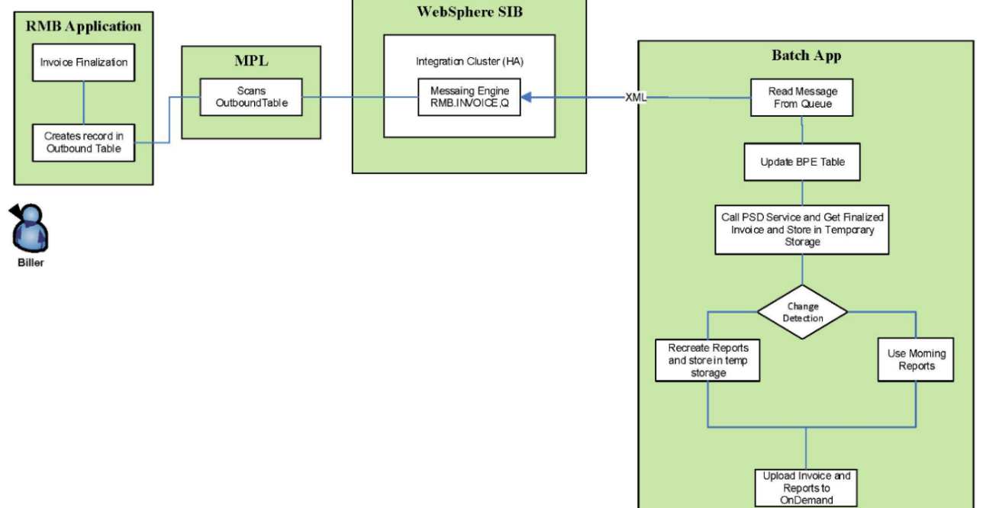

* **RMB Application:**
* User’s finalizes the pending invoice from the RMB application, which creates a record in the outbound table
* **MPL:**
* MPL application (oracle developed) scans the outbound table for the records and sends a message to the messaging Queue (SIB).
* **WebSphere (SIB):**
* The messaging engine (RMB.INVOICE.Q) picks the message and waits for the batch app process to read the message from queue.
* **BATCH APP:**
* This Processes reads the message and updates the BPE table.
* PSD service (used for generating the XML report and converting it to PDF invoice) processes the finalized invoice and store it in the temporary storage.
* The change detections process validates the report for changes from morning, if no changes publishes the same morning report else publishes the updated report.
* The updated XML invoice in PDF format and BO reports are published to On-demand

## System Process Flow of Finalized/Pending Bills:

The following illustrates the general process flow for billing an account and producing an invoice in ORMB.  The assumption is that the transaction consolidation and summarization process is run prior to the billing process, as the former is responsible for creating the ‘ready-to-bill’ billable charges.



* Each billing account in ORMB is configured with a bill cycle which holds the billing schedule of the account.  Accounts on an open bill cycle are selected by the Batch Billing process for billing.
* Unbilled billable charges for the transactional contracts of the billing account whose billable start and end date fall within the bill period are processed and a bill segment is created for each.  A bill segment is a financial transaction in ORMB and once frozen, impacts the account balance and general ledger.
* Recurring charges setup for transactional contracts of the billing account are evaluated, and if eligible for the bill period, a bill segment is created for each.
* For accounts that do not require a bill review, the bill segments are frozen and the bill is completed.  Only frozen bill segments impact the account balance and general ledger.
* For accounts that require a bill review, the bill segments are left unfrozen and the bill in a pending state.  A user must go in and determine if the bill is ok to be finalized or if it should be cancelled.
* An invoice extract is produced for bills that have been finalized. The extract is sent to Xpressions (XML file generator) to generate the Invoice Summary and to trigger Business Objects to generate the Invoice Reports.
* Bills that have been cancelled by the user go through a de-aggregation process, which reverses the aggregation of transactions details onto the billable charges.  The transaction records effectively return to a validated state, for reprocessing.

# Application configuration setup

## Customer/Group Setup

Customer denotes the client to which Anthem has contracted with. In Anthem ORMB customer is denoted as “Parent Customer”. Below are the steps to setup a new Parent Customer and its associated Product/Price setup.

1. Log into ORMB
2. Setting up a new customer form
3. From the Main Menu > New Customer Setup Form Template
4. Choose the appropriate template. Below are the available templates

**Common (Standard) or Separate Retention Invoice Template**

* + - Separate Retention Invoice Template (Choose option below)
* Used for Enroll-Based (Separate Invoices) Template
  + Groups with separate retention invoice
* Used for Self-Billed (Enrollment Based) Template
  + SRA Groups
* Common (Standard) Template
* Standard (Combination of Claims & Retention OR Claims Only) Template
  + Used for all other groups
  + Used for admin only groups

Click theCaptureicon to select the template. Fill all the required Customer information.

**Parent Customer & Billing Group Names**

If the group has only one billing group, we can use the ***Parent Customer* *Name*** as the ***Billing Group Name.*** If there are multiple billing groups to be created, the naming convention to be decided based on the customer needs. Parent Customer and Billing groups are 1 to many in relationship.

**Umbrella Contract Dates**

If this group has an existing contract in PeopleSoft, previous year’s contract period is entered here.

* The most current contract period will be added later under the group’s billing group screen.
* (In general, the group will have 2 umbrella contracts before submitting for approval)

**Contacts**

Choose the appropriate Account Manager, Under Writer, Biller, Reviewer by selecting the Capture1 icon and typing the name.

Click the Create Customer button and the Parent customer should get created successfully.

**Searching Customer**

On the Control Central Screen, search again for the customer you just created. Click the **Capture2** under ‘Edit Parent Customer’

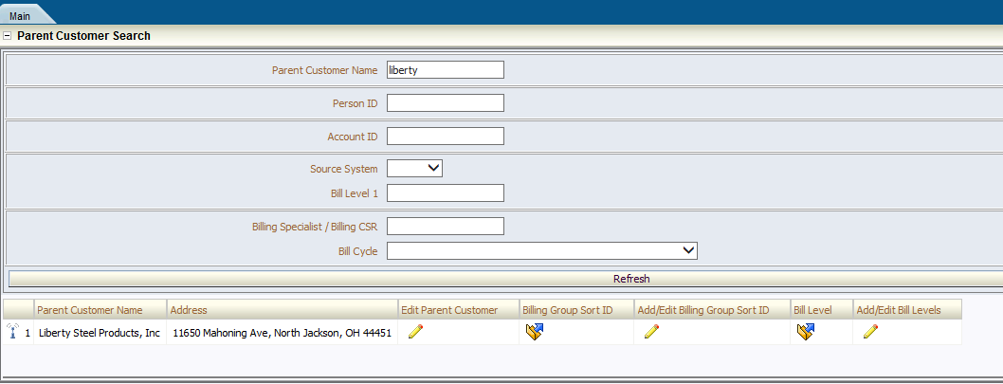

* Main tab holds all the person details information that was previously inputted. This screen can be used for reviewing the information for accuracy.
* Contact Information holds all the mailing address of the customer.
* Characteristics Tab holds all the characteristics defined for that Parent customer.
* The History drop down is used to go back to Control Central screen.

Below screenshot represents the same.

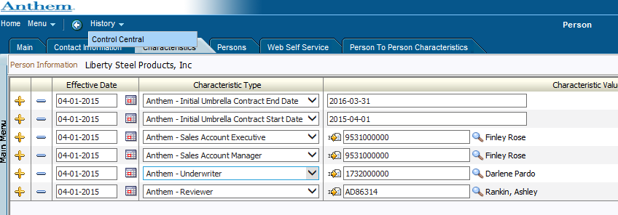

**Adding Sort IDs**

In RMB, Sort IDs are used in reporting to sort the transactions based on the specified rules. Below are some of the Sort IDs characteristics and the general values across different source systems.

* Sort IDs will be a 4 digit numerical value
* By default 9999 Sort ID will be auto populated. If 9999 is already used, change the Description from Default to the subgroup name that belongs to 9999.
* Below are the steps and characteristics to define Sort ID’s
* Click the Capture6 to add additional Sort Ids
* Don’t end date sort IDs
* Every Sort ID should be accompanied by a description
* Be sure to save each line after adding it. You cannot save more than one line at a time.
* For WGS and NASCO groups, the first sort ID will be 0001 while Facets groups will mimic whatever is in Facets.

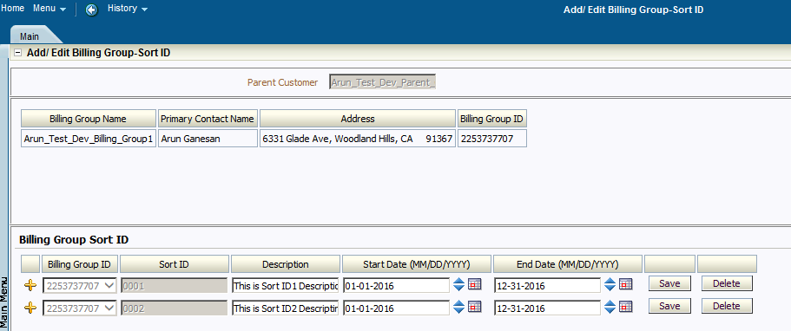

**Adding Bill Levels**

In RMB, Bill levels are used to determine at which bill level the transactions needs to be billed to the customer.

Below are some of the Bill level rules and characteristics while setup.

* + - Effective date needs to be the date of the first RMB Umbrella contract
    - Credit Switch is always Recovery default bill level (only)
    - Bill Level 1 = Group ID
    - Bill Level 2 = Sub Group ID
    - Bill Level 3 = Product/Health Plans. It is not always necessary for Bill level 3 as this is just for Sort ID (reporting) purposes.
    - Always add a default bill level
    - Status Flag is always Active

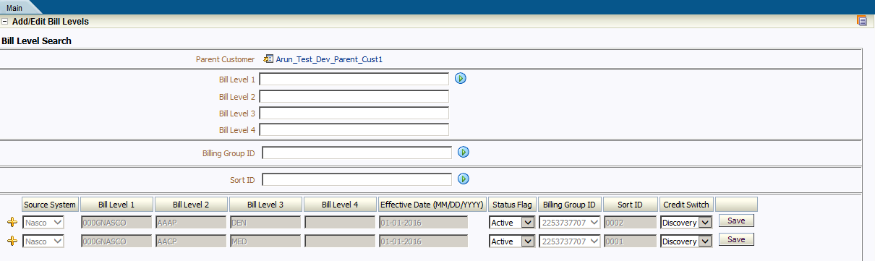

**Account Setup**

An account in RMB is associated with a user. Account holds different characteristics values that needs to be applied for the customer. Below are some of the rules/characteristics applied for an account.

* **Setup Date** – Date at which the account is setup.
* **Management Group** needs to be listed as CNTL-ASO (Central Local ASO Billing)
* **Bill Cycle**
  + CDHP groups will be on a Mon Monthly Claims – Monthly Admin 2nd Full Week (have until Friday to send to group)
  + Weekly groups will select the appropriate day with admin 1st full week
  + Admin only groups will set their schedule to Monthly Claims and Admin billed on the 3rd, 15th, or 7th
* **Bill After Date** – Date after which the group to start the billing
* **Persons Tab**
  + “Bill Route Type” - In Anthem RMB, the value used is ‘Email’
  + The drop down box at the bottom “Address Source” needs to be set to ‘Person’ (ensure address is displayed)
* Bill Message Tab, type IFEE in the “Bill Message” and set to ‘Permanent’
* C&C Tab, ensure “Standard ASO” is selected under “Collection Class”
* Characteristics Tab
  + Account Type: STANDARD even for CDHP
  + Invoice Presentment Option: IPO1
  + Select the biller
  + Set the payment method
* DD for demand debit
* CHK if paying by physical check
* WIRE if the group pays by ACH
  + Set the net days *(please note that RMB accounts for weekends and holidays)*
  + Set Cash Display Option to “NONE”
  + Click Save

## Pricing Setup

**Pricing Rules**

Pricing determines the rate at which a product needs to be priced for the customer. A customer may have changes to the rates/rules for a product over time. This is managed by Pricing Rules start and end date. Products with different rates/rules for the various bill levels/subgroups under a Billing Group have Pricing Rules which reference a Pricing Group. A Pricing Group is a set of Pricing Group Rules which identify the bill levels/subgroups where a different each rate/rule variation is applicable. The set of bill levels/subgroups are stored as Pricing Group Rule Bill Levels. Associating a Pricing Rule with a Pricing Group allows rates/rules to be defined for each Pricing Group Rule under it. Pricing rule can be added at parent customer and billing group level. Rules/rates apply to all bill levels/subgroups under the Parent Customer. To add pricing rules, click **Add Pricing Rules** Button on control central screen

Claims can be loaded at parent. If there are no pricing groups (only one admin rate), admin can also be loaded at parent. If there are pricing groups (more than one admin rate), admin pricing rules need to be loaded under the umbrella contract. ***Pricing Groups need to be set up before pricing rules are set up (***See Pricing groups section below for setup instructions). Add a claim rule and admin pricing rule for each contract year

**Below are the different bill cycle Schedules:**

|  |  |
| --- | --- |
| **Bill Cycle** | **Claims Aggregation** |
| Monday Weekly | Monday- Sunday |
| Tuesday Weekly | Tuesday- Monday |
| Wednesday Weekly | Wednesday- Tuesday |
| Thursday Weekly | Thursday- Wednesday |
| Friday Weekly | Friday- Thursday |
| Daily | Prior Day (i.e. on Tuesday it bills Monday’s claims) |
| Monthly | Prior Month (i.e. in Nov it bills claims for Oct 1-31) |

**ITS Fees**

* Funding document will indicate if ITS AEA and ITS Access Fees are to be billed
* ITS Surcharge, ITS Supplemental, NY Surcharge, and Risk Withhold are always checked
* If they **ARE** billed, check ITS CFA, ITS Transaction and NCN (unless they don't have it)
* If they **ARE NOT** billed, make sure to uncheck all boxes except for ITS Surcharge, ITS Supplemental, NY Surcharge, and Risk Withhold are always checked
* Neverchange the Initial Umbrella Contract end or start date on Characteristics at parent.

**Pricing Groups**

Pricing groups are defined for the respective billing groups that are created under the parent customer. Below are the steps used to define a Pricing Group:

* To add pricing groups, click on your billing group and go down to the Umbrella Contract section.
  + - * Broadcast the contract to add a pricing group.
      * Click “Add/View Pricing Groups”
      * Click “Add” in the top right corner of the screen
* Priority 10, 20, 30
* System will read the lowest number first, so we should have the most specific rule defined for the lowest number
  + - Do this in increments of 10 so there is room to add more later

Example

10- Dental Only

20- Medical & Dental

30 Medical Only

* Description defines the “WHAT”
  + - Medical
    - Dental
    - Medical and Dental
* Rule defines the “**WHERE**”
  + - * Parent
      * Package
      * 4th byte of P
* Pick source System
* Bill level 1 (GID)
* Bill Level 2 Leave blank
* Bill Level 3 (Choose what Health plan or Package code will receive those specific rates)

**Pricing Rule for Billing Group**

To define Pricing Rule for the Pricing group, below are the steps to be followed.

* Select Retention type
* Select the pricing group created in the previous step

For Example, if we have 3 Pricing Groups (**Dental Only, Medical & Dental, and Medical Only**), each type of Health Coverage Class should be added for each pricing group.

In the example screenshot, above we have a Medical Rate and a Dental Rate.

* + After each Health Care Coverage Classes are added, type the rates in the Pricing Group Rule that the Health Care Coverage applies to.
  + In this case the “MEDICAL Only” & the “Dental/Medical” will both receive the Medical rate as shown above.
  + Move down to Dental Health Coverage and enter the dental rate in the Pricing Group Rule it applies to
  + In this case the Dental Rule is entered in the “Dental Only” and “Dental/Medical”
  + **Please note the rates should NEVER be COMBINED**.

## Reports Setup

Reports needs to be setup for each billing group. This will make sure once the bill is generated, the corresponding reports will also get generated for the billers to finalize the bill.

Below are the steps carried to setup the reports.

* Click on billing group.
* Under Current Context box (Top right corner) Click the icon below.
* Go to **“Go to Account Reports”**
* Choose reports as needed. (Please use the options listed below)
  + Make sure all the field codes are checked that are listed under each report described below
  + Do not change the “Output Format” or “Frequency” of each report

**Below are the different reports generated on a regular business needs.**

**Enrollment Sub/Member Detail with PHI**

* Sort ID
* SORT ID Desc
* Bill lvl 1-4
* Last Name
* First Name
* Middle
* Source system
* EID only upon request
* HCID
* sex/relationship

**Enrollment Member/Subscriber Detail No-PHI Reports need to have**:

* Sort ID
* Sort ID Desc
* Bill lvl 1-4
* Source System
* Sex/relationship

**Ancillary/Manual Charges Report (formerly INV0300**)

* Make sure this is on all accounts. Add Below
* First and Last Name
* Incurred date
* Paid Date

**Enrollment Summary (formerly INV0200)**

* Sort ID
* Sort ID Description

**Invoice Summary CDHP Blend Bill LVL 1 Summary**

* Sort ID
* Sort ID Description

**Invoice Summary by Sort ID**

* Sort ID and Desc need to be selected

**Claims Detail (CDH Blended)**

* HCID
* EID only if requested
* Last Name
* First Name
* Source System
* Sex/Relation
* No fee breakouts unless requested

**Claims Detail No PHI+ fees included in claim amount**

* Source Sys
* Sex/Relation

**Claims Detail w/ PHI + Fees included in claim amount**

* HCID
* EID only upon request
* First Name
* Last Name
* Src System
* Sex/Relation

## Billing

The billing solution describes how invoices are produced for billing accounts in ORMB.

* Bills are typically generated for accounts on a pre-defined billing cycle (e.g. Weekly, bi-weekly, monthly etc.) via bill run batch process or manually on ad-hoc basis
* Each Billing account in ORMB is configured with a bill cycle which holds the bill schedule of an account.
* Unbilled billable charges for a transactional contract of a billing account whose billable start and end date fall within the bill period are processed and a bill segment id created for each.
* A bill segment is a financial transaction in ORMB and once frozen, impacts the account balance and general ledger.
* Recurring charges setup for transactional contracts of the billing account are evaluated, and if eligible for the bill period, a bill segment is created for each.
* For accounts that do not require a bill review, the bill segments are frozen and the bill is completed. Only frozen bill segments impact the account balance and general ledger.
* For accounts that require a bill review, the bill segments are left unfrozen and the bill in a pending state. A user must go in and determine if the bill is ok to be finalized or if it should be cancelled.
* Bills that have been cancelled by the user go through a de-aggregation process, which reverses the aggregation of transactions details onto the billable charges. The transaction records effectively return to a validated state, for reprocessing.

Below diagram shows the bill generated after the billable charges are created.

## Payments

* A payment reduces how much an account owes. A payment is linked to an account which over time, many payments may be applied to an account’s debt.
* Payments are being matched against account’s unpaid bills. The system can create one or many match events when a payment is added. This match event matches the payment's credit financial transaction’s (FT) with the debit and credit FT's from bills (i.e. bill segment). The FTs’ that are linked to the match event are controlled by the payment's match type and match value.
* WellPoint customers can make a payment using the following methods:
* ORMB Initiated
  + - Demand Debit (Standard Method)
* Customer Initiated
  + ACH/Wire Customer Initiated
  + Check (Live Check)
* **Payment Process flow**

The diagram below represents the general flow of the Payment process in ORMB.



Payments are initially created in the In-complete state. Payments in this state don't have payment segments or financial transactions; they are simply a stub awaiting distribution.

When payment distribution happens:

* If the system cannot distribute the payment (for whatever reason), the payment is moved to the Error state. Payments in this state can be deleted.
* If the system successfully distributes a payment, the payment becomes Freezable. Payments in this state can be deleted.

Freezing the payment causes the following to occur:

* The system executes any payment freeze algorithms linked to the account's [customer class](http://fsmdc-vm1:6500/ouaf/help/ENG/C1/C1_04Custom_Customer_Class_Controls.html) and to the service agreement's [Contract type](http://fsmdc-vm1:6500/ouaf/help/ENG/C1/C1_13SAType_SA_Type_Algorithms.html).
* The payment's state becomes “Frozen”. Payments may not change once it is frozen. However, it can be cancelled and reverse the payment's financial affect.
* Payment scenarios implemented in Anthem.
* Manual Payments
* Apply a Single Payment Against an Invoice. Payment Amount equal to Invoice Amount.
* Underpayment against an Invoice
* Overpayment against an Invoice
* Single Payment against multiple invoices
* Apply payment directly to on-account cash (Overpayment Contract)
* Apply payment directly to unidentified cash (Suspense Contract)
* Apply payment to the invoice with the matching bill amount
* Transfer Payments: This scenario explains how payments incorrectly applied in ORMB will be transferred other accounts or out of ORMB to other WellPoint Systems.
* Transfer Cash from unidentified to on-account cash
* Transfer Cash from unidentified cash to an invoice
* Transfer Cash from on-account cash to an invoice
* Transfer Cash from unidentified cash to multiple invoices
* Transfer Cash out of ORMB to WellPoint Other Systems
* Transfer Cash into ORMB from WellPoint Other Systems
* Cancel Payments: A payment event has tender(s) and payment(s). We can cancel a tender when it's not valid, e.g., when a check bounces. We can also cancel a payment when the account should not have received the payment (e.g., a misdistribution or a canceled tender).
* Cancel Payment Tender
* Cancel Payment
* Auto Payment
* Create a Systematic Debit Auto Pay transaction
* Manually stop a Debit Auto Pay transaction prior to extraction
* Create a manual debit Auto Pay Transaction
  + Manual Payment process. All ACH/Wire and Check payments will be added manually in ORMB. In order to add manual payments, the CSR or user can use ‘Add Payment Event’ to add single payments or ‘Payment Upload Template’ to add multiple payments.
* Add Payment Event: For details on Add Payment Event please refer to online help – Oracle Revenue Management and Billing Business Processes 🡪 Payments 🡪 Maintaining Payment Events.

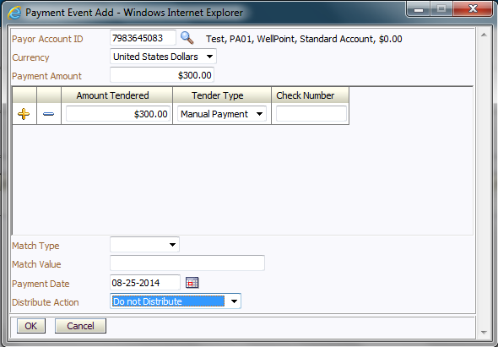

* + Payment Upload Template: WellPoint receives customer initiated payments through various sources. After the payments are verified, they are collected on excel spreadsheets. WellPoint requires the ability to load the payments from these spreadsheets into ORMB.
* Base ORMB provides a user interface to upload the payments as per the Payment Upload Template a CSV file format.
* File records are initially moved to Pre Staging tables, records are then moved to payment staging tables using the button available.
* Once the records are moved to Payment staging tables Create Payments button is enabled to trigger the PUPL batch.
* This batch creates the Payment Event, Payment Tender and Payments.

A user interface is available in ORMB to upload the payments into the Payment Staging Tables. User will click Browse and select a file to upload the Payments. The file will be in a pre-defined CSV file. Payment upload UI will be navigated from main > Financial > Payment Upload

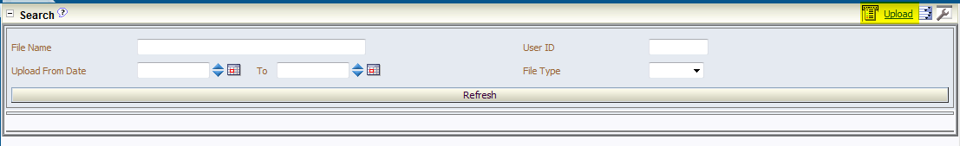

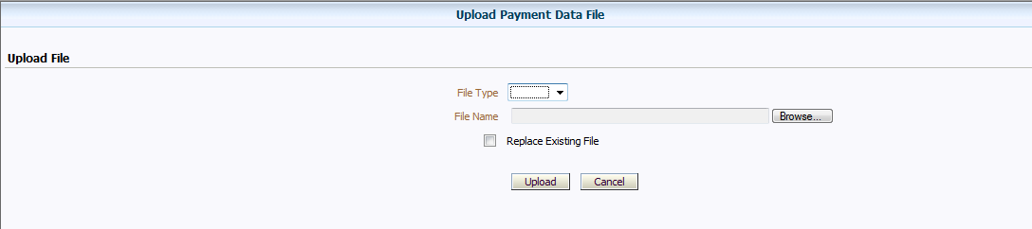

Once the file is selected and uploaded, it can be searched from the search zone.

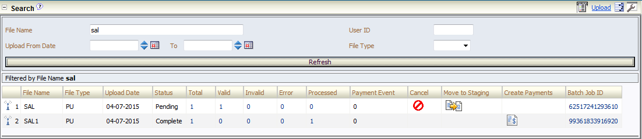

* Auto Payments: All Demand Debit (Auto Payments) Payments will be processed using ORMB’s Auto Payment functionality. All Auto Payments will be initiated by ORMB. In order to initiate a payment, ORMB requires the customer’s bank information stored and maintained in ORMB. The Customer’s Bank information will be captured as part of Customer Setup.
* As part of customer setup, the CSR or an authorized user may add or update Auto Pay information. A new user interface will be developed to capture the Customers Bank Account Information.
  + To Add the Customer’s Bank Information navigate from the Account Context Menu 🡪 Go To Account Auto Pay.

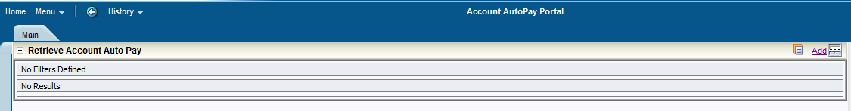

* + Click on Add to Add Customer’s Bank Account Information.
  + Enter Customers Bank Account Information
  + Enter Maximum Withdrawal Amount if any

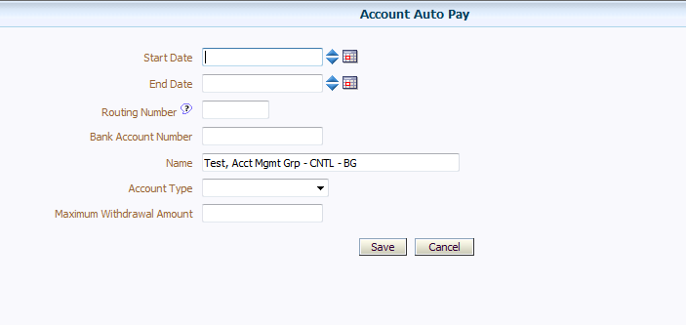

* + Click on Save.
* Approval process for new customer.
  + New Customer Setup – DD information approved as part of the Net Customer Setup Approval Process.
  + Add Billing Group - DD information approved as part of the New Billing Group Approval Process.
  + At customers request after the new customer or the billing group have been approved. The approval process for this will be triggered using the Maker / Checker process.
* Auto Payments Amount calculation.
* ORMB calculates Automatic Payment amount when Billing process (Bill Completion) takes place.
* If the Automatic Payment Amount is a debit the system initiates the Auto Payment Process.
* If the calculated auto payment amount is zero or a credit the Auto Payment Process is not initiated.
* In addition, system will compare the calculated payment amount to the maximum withdrawal amount and if the maximum withdrawal amount is less than the calculated payment amount; the system creates a To Do to notify the user and uses the maximum withdrawal amount.
* Auto payment dates calculation
* ORMB provides an “Auto Payment Date Calculation Algorithm”. This algorithm helps calculate the Auto Payment Dates (Extract date, Payment date and the GL Distribution Date) based on parameters defined on the algorithm.

For WellPoint these dates will be calculated as follows

* + Extract Date = Invoice Due Date – 2
  + Payment Date = Extract Date + 2
  + GL Distribution Date = Extract Date + 2
* Custom payment Algorithm for Anthem
* CM_OVRRD – Override Due Date

Due Date of a Bill is driven by the Due Dates field defined on the Customer Class. However, this algorithm is used to override a Bill’s Due Date.

This algorithm has 2 parameters

* + The first parameter drives the due date based on the Payment Terms Characteristic defined on the Account
  + The second parameter overrides the due date defined based on the Override Due Date Parameter defined on the Account. If both the characteristics are available on the account, the second characteristic – WLP-OVDD takes the precedence. This characteristic is populated on the account only on an exception basis when a particular bill needs a due date other than the one derived by Payment Terms. This characteristic is deleted on Bill Completion and hence it’s applicable only for a particular invoice.
* PYDS-TRN-LVL – Payment Distribution :

This Algorithm is used only for Open Item Accounting. This algorithm is used in conjunction with the matching algorithms used on match types.

* PAY FRZ O-I – Link Payment FT’s to Match Events

This Algorithm is used only for Open Item Accounting. This payment freeze algorithm will link financial transactions (FT's) to match events.

* CI_CFTZ_COFT – Keep Original Match Event

This Algorithm is used only for Open Item Accounting. This FT Freeze Algorithm is designed to be used along with the matching algorithms and the payment distribution algorithms.

* CI_PDOV_PYBL – Pay Specific Bill

This algorithm is used only for Open Item Accounting. This matching algorithm will first pay the bill specified in the match value and excess amount will be applied to an Over-payment or on-account.

* CI_PDOC_PYSA – Distribute Payment by Contract ID

This payment match type algorithm is used to match a payment to a specific contract. This algorithm is used to apply cash directly to an Overpayment Contract (On-Account Cash) or Unidentified / Unprocessed cash.

* CM-APAM-DFLT – Auto Payment Amount Calculation
* This algorithm is used to calculate the Auto Payment Amount. There are 2 options available – current charges or netting.
* Netting is set if the Override Calculation Basis is populated with ‘A’ – Account Balance.
* At WellPoint, the demand debit transactions will not be netted.
* APAYDFLTCR – Auto Pay Record Creation Algorithm
* APAY-DTCALC – Auto Pay Date Calculation

# ADJUSTMENTS

## Refund

Oracle Revenue Management and Billing allows to refund amount to the account. Refund is allowed only in the following scenarios

* If the amount received from the payer account is matched against the suspense or on-account cash (excess credit contract) the system facilitates to refund the amount to the payer.
* We can refund the amount of a credit bill line item, such as credit bill segment or adjustment, if required. However, in case of Anthem this scenario is not applicable as credit invoices are systematically closed and the credit balance is transferred to the on-account cash.

To refund the amount to the account holder, you need to create refund adjustments through a refund request. While creating a refund request, you need to specify the refund request type using which you want to create the refund request. It is the refund request type which helps the system to determine:

* Whether the refund request must be approved before creating refund adjustments in the system
* Approval profile using which the refund request must be approved
* Whether multi-level or single-level approval is required while creating refund adjustments in the system
* Tolerance limit for refund (i.e. minimum refund amount)
* Adjustment type using which the write up adjustment must be created when the total refund amount is less than the minimum refund amount
* Default adjustment type using which refund adjustments must be created

The system allows to create refund adjustments only using those adjustment types where A/P request type is defined. Once the refund adjustments are created, the A/P Extract process will extract the information and accordingly refund the amount to the payer. During the refund request process, a refund request goes through various statuses in its lifecycle.

**Create a Refund Request**

To create a Refund Request

* Navigate to Main Menu🡪 Financial 🡪 + Refund/Write off Request.
* Select Request Type screen appears.
* Click the Add link in the upper right corner of the Search Refund/Write Off Request zone

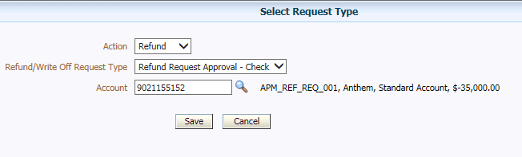

For a Refund Request Action should be ‘Refund’

Select a Refund Request Type

* Click Save.
* The refund request is defined and the status of the refund request is set to Draft. The Refund Request screen appears with the details of the refund request. It contains the following tabs:
* Main – Displays information about the refund request. It contains the following zones:

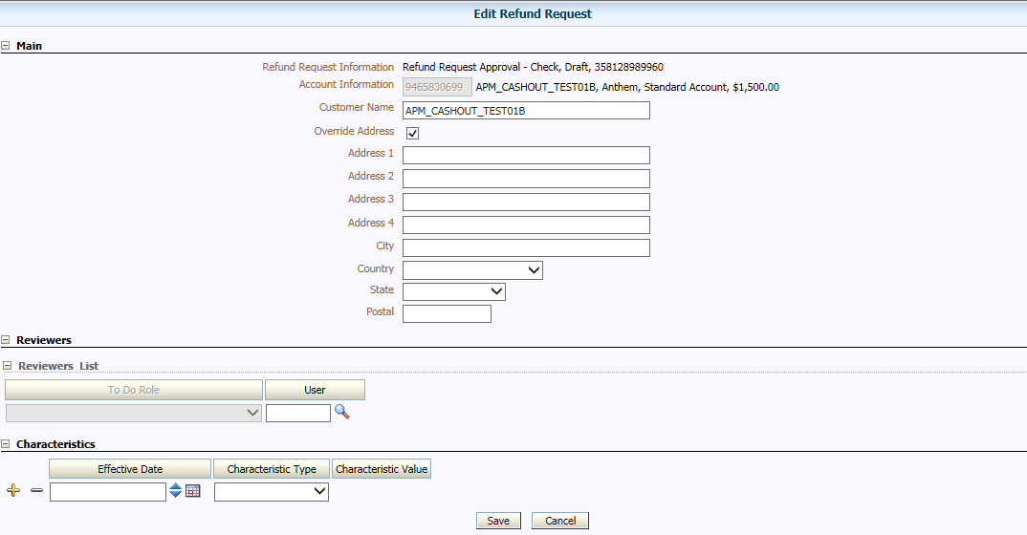

Account of the Person who is supposed to receive the refund

Address override for A/P Check refund

* + Refund Request – Displays the details of the refund request.
  + Refund Details – Lists the entities, such as payment events, payments, and/or credit bill line items (such as credit bill segments and adjustments), of the account which must be refunded.
  + Characteristics – A new characteristic type of attachment will be configured. Users will use this characteristic type to add a single file attachment, which could be retrieved by other approvers during the approval process.
  + Reviewers – A list of reviewer roles and users required to approve the refund adjustment.
* Payments — used to search payment events or individual payments that you want to refund. This tab appears only when the refund request is in the Draft status.
* Log – Lists the complete trail of actions performed on the refund request.

## Write-Off

A write-off removes an accounts receivable (A/R) amount is unrecoverable. Biller can write off billed segments that meets certain conditions.

**Create a Write-off Request**

To create a Write-off Request

* Populate the Adjustment Details
  + Main Tab
* Contract – Contract Type needs to be “Standard” Contract
* Adjustment Type – “WR-OFFRO” – “Run Out – Write Off Adjustment”
* Amount – Amount must be the reversal of the Bill Segment Amount
  + Navigate to the Characteristic Tab
* Populate the Bill Segment ID to be written off
  + Navigate back to Main Tab
* Click Generate

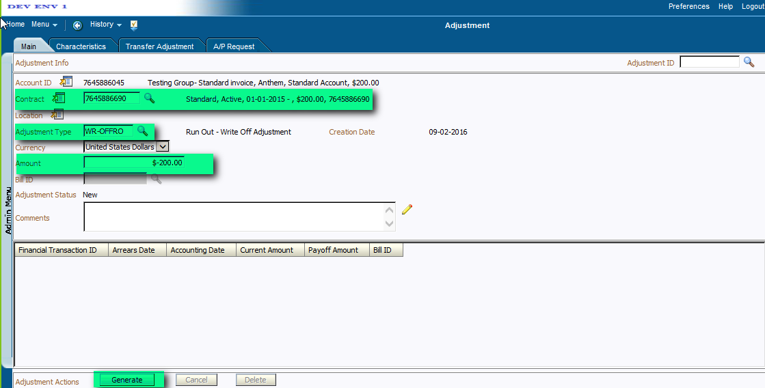

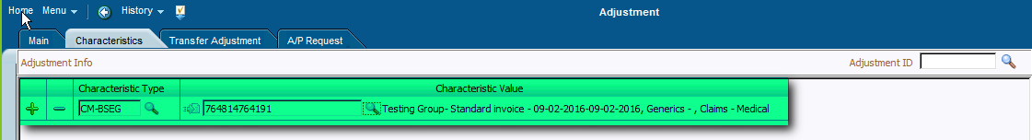

* Click Calculate

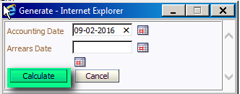

* Click Freeze

# Transaction Feed Management

## Functional Overview

ORMB’s Transaction Feed Management (TFM) process enables processing of transactions covering the details of product usage by the customers. This process involves importing the product charges and SQ calculation from the transaction data received into system involving the execution of multiple batch programs. TFM is a nightly process. Several batch jobs are executed in sequence overnight to create billable charges and bills.

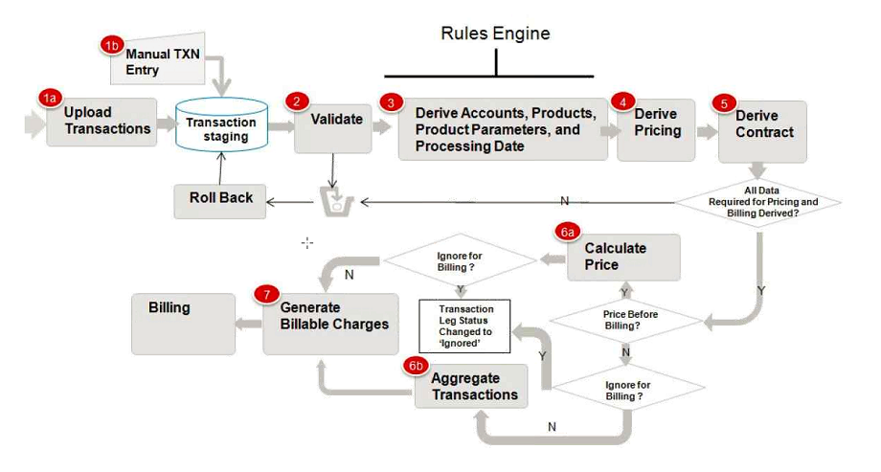

*Diagram reference: Oracle's TFM Process Document*

Following sequence is followed when TFM process is run:

|  |  |  |
| --- | --- | --- |
| **Batch Sequence Table Sequence** | **Batch Control** | **Description** |
| 2.1 | C1-TXNRB | Rollback Batch |
| 2.2 | F1-FLUSH | Flush All Batch |
| 2.3 | C1-TXNHV | Header Validation Batch |
| 2.4 | C1-TXNIP | Initial Product Determination Batch |
| 2.5 | C1-TXNVP | Product Pricing Verification Batch |
| 2.6 | C1-TXNEX | Update Status Batch |
| 2.7 | C1-TXNSQ | SQ Calculation Batch |
| 2.8 | C1-TXNCM | Mark Completion Batch |
| 2.9 | C1-TXNCU | Clean Up Batch |
| 2.10 | BILLING | Billing Batch |

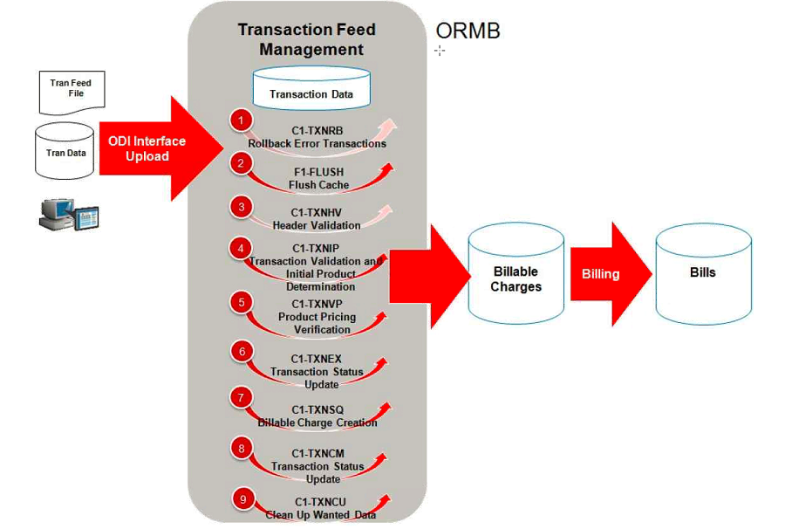

*Diagram reference: Oracle's TFM Process Document*

* For aggregation, the batches from 2.2 to 2.8 (F1-FLUSH, C1-TXNIP, C1-TXNVP, C1-TXNEX, C1-TXNSQ, C1-TXNCM, C1-TXNCU) must be run in the sequence.
* For roll backing the EROR or IGNR transactions, 2.1 (C1-TXNRB) batch must be run. It will change the transaction status to “UPLD” status.
* For disaggregation, 2.10 to 2.11 (C1-DISTG, C1-TXNDA) batches together must be run in sequence.
* For cancellation of the transaction, 2.12 (C1-TXCNC) batch must be run. After running cancellation, all the batches for aggregation from 2.2 to 2.8 (F1-FLUSH, C1-TXNIP, C1-TXNVP, C1-TXNEX, C1-TXNSQ, C1-TXNCM, C1-TXNCU) must be run in the sequence. This batch can be run at any point of time.
* No batch should be run twice in the sequence. If any batch is run twice, the disaggregation batch must be run for all the transactions. This should be followed by complete aggregation process 2.2 to 2.8 (F1-FLUSH, C1-TXNIP, C1-TXNVP, C1-TXNEX, C1-TXNSQ, C1-TXNCM, C1-TXNCU) in the sequence.
* While running the batches, if any configuration is changed then the disaggregation batch for all the transactions must be run.

## Technical Overview

* The sources for TFM can be found by accessing Admin Menu, T, and Transaction Source. The different sources available are CAP – Capitation Feed, CLM – Claim Feed, ENR – Enrollment Feed, GEN – Generics Feed, PC2 – Payment Innovation Feed.

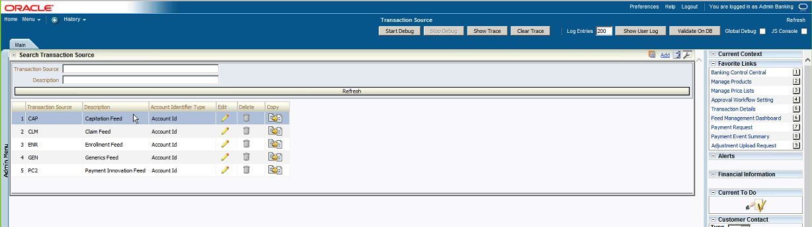

* The Transaction Record Type can be viewed by selecting Admin Menu, T, and Transaction Record Type. From the Transaction Record Type screen a record type can be selected and broadcasted using broadcast icon next to the record type value. This will bring up the details of the record type including the associated rule type.

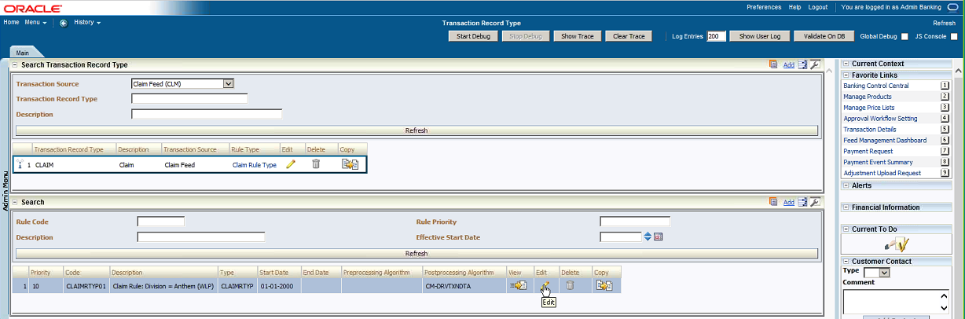

* The Transaction Record Type can be edited by clicking on the ‘Edit’ icon next to Transaction Record Type. On the Transaction Record Type screen that pops up, changes can be made and saved.

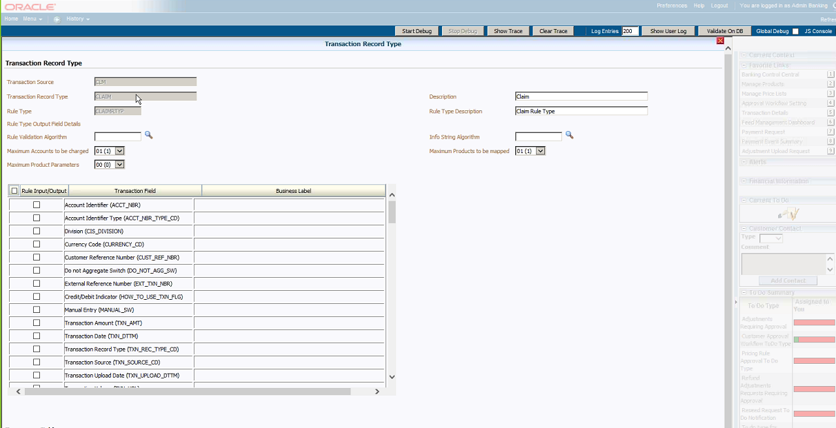

* Rule Type is an ORMB functionality used to define criteria on how the transaction should be processed. E.g., Maximum transactions to be processed: is the max number of products that can be mapped to a transaction record type. In order to view the Rule Type applied to the record, the edit icon can be clicked… Once the Add Rule screen pops up, the rule type can be edited and saved.

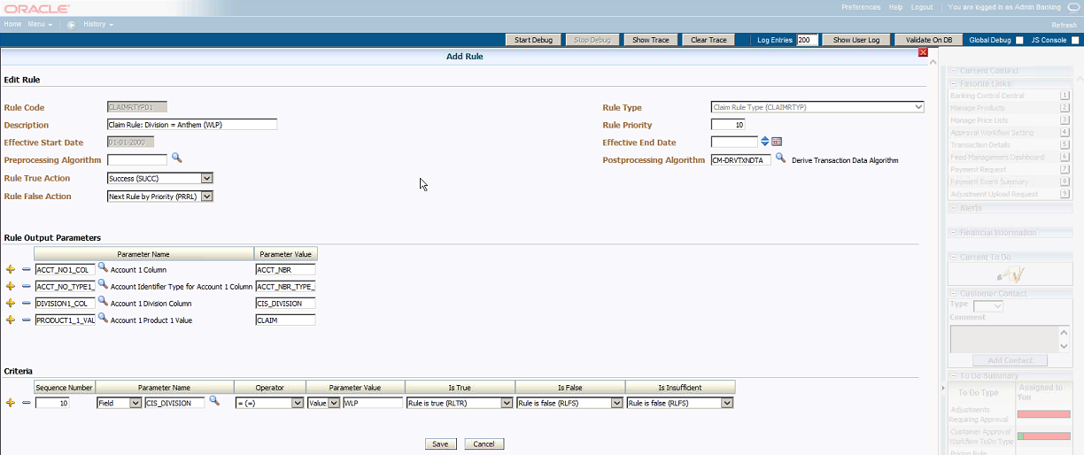

* After transaction record type is defined, the Rule Type needs to be defined to determine how a transaction needs to be processed. How a transaction is processed depends on the rule and the criteria defined under the rule. Rule Output Parameters, Criteria, Post Processing Algorithms, Pre Processing Algorithms need to be defined under the Rule
* Post processing algorithm is used for determining additional products other than standard algorithms (e.g., discount arrangements, stop loss for claims).
* Note that, if none of the rules are applicable to a particular transaction, the transaction will error out.

**Processing:**

* Once TFM processes the transactions from C1_TXN_DETAIL_STG, they will be moved to C1_TXN_DETAIL

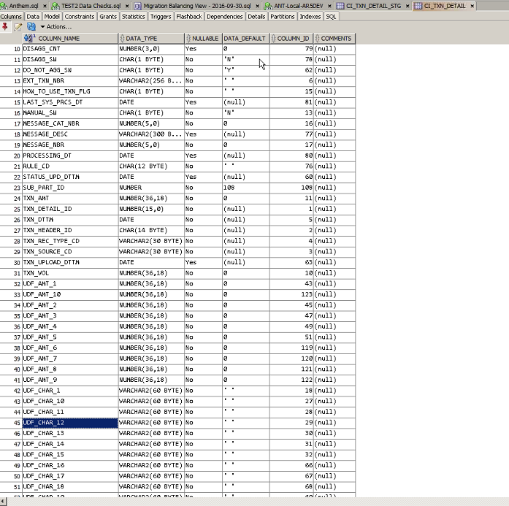

* C1_TXNIP applies rules to the transaction tables. Pricing rules can be added at the Parent Customer that apply to all billing groups. They can be applied at Umbrella Contract level under a specific billing group. They can also be defined as at a bill level.
* Anything that is not priced at parent customer, billing group or bill level is priced using Anthem Default Pricelist. Anthem Default PriceList can be accessed by selecting Main Menu, Pricing Management, and Manage Pricelist.
* Note that, Generics have been defined as pass through with anthem default pricelist in anthem implementation.

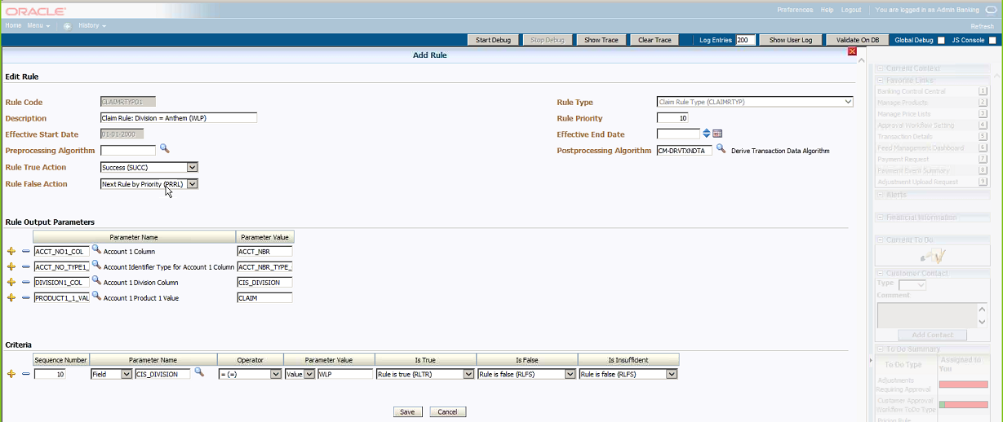

* The list of rules available can be viewed through Admin Menu, R and Rule…

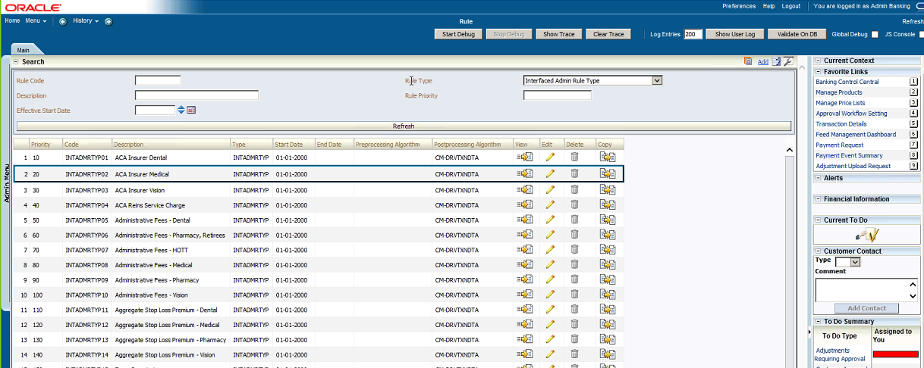

* C1_TXNIP invokes the rules and move transactions from C1_TXN_DETAIL_STG to C1_TXN_DETAIL based on the rules. RULE_CD column shows the rules applied to the transactions.
* C1_TXN_DTL_PRITM_SUMMARY table is a work table used only during TFM processing. This table is cleared out as soon as processing cycle is completed. It's used for summarizing the transactions that are currently part of TFM load. This will be particularly useful in the context of aggregation as long as the criteria is the same for them and the dates are within the aggregation period
* Aggregation Parameter Group ID represents a certain set of parameters that are Anthem specific which indicate whether the transactions need to be grouped together or not
* C1_TXNVP process is used to get the pricing based on price assignments and pricelists for Anthem customers and assigning pricing to the summary records in C1_TXN_DTL_PRITM_SUMMARY table. FIN_PRICEITEM_CD shows the pricing assigned to the summary records. PRICE_ASSGN_ID is the primary key for the pricing table. Rating Criteria is used for daily rating (RITA - rate individual transactions and aggregate calc lines across). All transaction types are daily rated for Anthem
* C1_TXNEX invokes the rating for individual transactions in C1_TXN_DTL_PRITM table. TXN_CALC_ID is populated after the rating process is completed. C1_TXN_CALC table shows the calculated amount under CALC_AMT.
* The following tables are populated by C1_TXNEX and are referenced for billable charge creation for corresponding functional attributes –
  + C1_TXN_CALC – header
  + C1_TXN_CALC_LN – detail
  + C1_TXN_CALC_LN_CHAR – characteristics
  + C1_TXN_SQ - Service Quantity
* C1_TXNSQ is the process that creates the billable charges. Its role is to do final checks on which transactions got processed and generate billable charges. Errors out transactions that are not processed
* C1_TXNCM marks the transactions as completed. C1_TXNCU cleans up the transactions in the summary table

**Scheduling:** All the TFM jobs are scheduled through Control M and are run on a nightly basis. However, in the event of a need to run them manually (e.g., for the purposes of testing), they can be submitted through the following Batch Job Submission screen. This screen can be accessed through Main Menu, Transaction Feed Management and Batch Job Submission

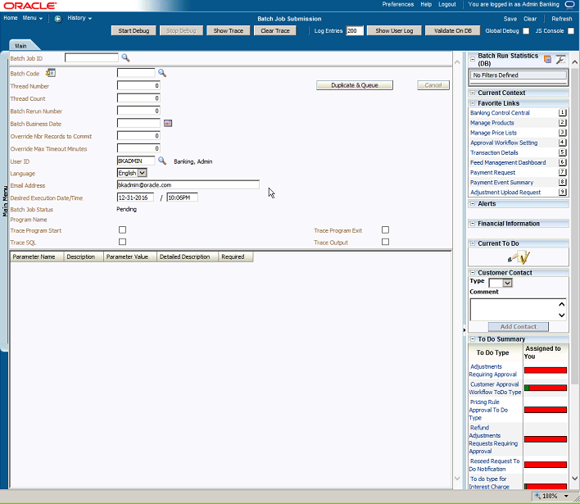

The attached Visio document illustrates the TFM process with an example



# Stop loss functionality

## Overview

Stop-loss or Excess insurance is a product that provides protection for ASO or Self-insured employers by serving as a reimbursement mechanism for catastrophic claims exceeding pre-determined levels. The significant difference between stop-loss and a conventional employee benefit insurance is that stop-loss insures only the employer. Stop-loss does not insure employees.

**Types of Stop Loss:**

1. Specific Stop-Loss: - The form of excess risk coverage that provides protection for the employer against a high claim on any one individual. This is protection against abnormal severity of a single claim rather than abnormal frequency of claims in total. Specific stop-loss is also known as individual stop-loss.
2. Aggregate Stop-Loss: - A ceiling on the dollar amount of eligible expenses that an employer would pay, in total, during a contract period. The carrier reimburses the employer after the end of the contract period for aggregate claims.

## Stop Loss Customer Setup

* **Log into ORMB**
* **Setting up a new customer form –** Setting up a Stop Loss Parent customer is very similar to the general customer setup. Please refer the customer setup section to complete the initial customer setup.

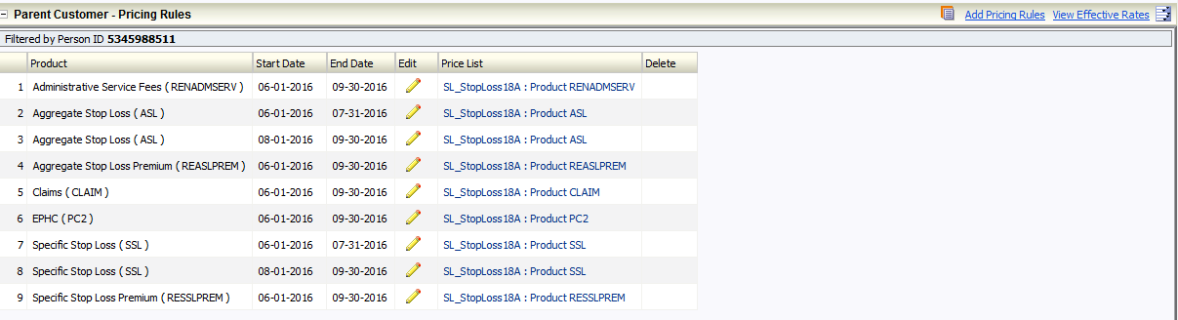

* **Parent Customer Pricing Rule Setup** 
  + **Specific Stop Loss parameters**

The first step in setting up a price rule is to create a SSL Pricing rule and set it parameters. The Specific Stop Loss Arrangement parameters are stored in the Pricing Rule entity (Table Name - CM_PRC_RULE) defined on the parent customer.

Below are the steps to create a Pricing Rule SSL

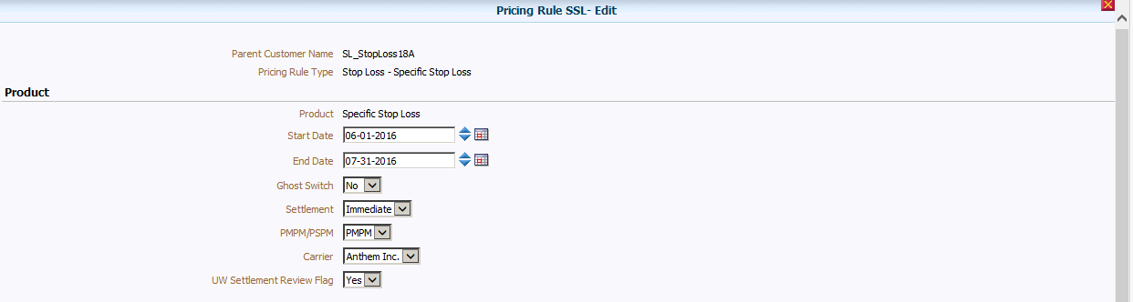

* + Click Add Pricing Rule to setup the SSL pricing type
  + Choose the Pricing Rule Type as Stop Loss – Specific Stop Loss and click Ok.
  + Select the Product as SSL and provide the Start and end dates.
  + A Ghost Switch can be chosen as Yes, if the settlement need not be given back to customer. Otherwise choose No
  + Provide the settlement frequency
  + Valid values are in lookup SETTLEMENT_FREQUENCY_FLG:
* ANNL - Annual
* IMMD - Immediate
* NEVR - Never PMPM/PSPM
  + Choose the accum level as Per Member Per Month or Per Subscriber Per Month.
  + Select the carrier as Anthem.
  + Choose the UW Settlement Review Flag as Yes for the underwriter to receive reports

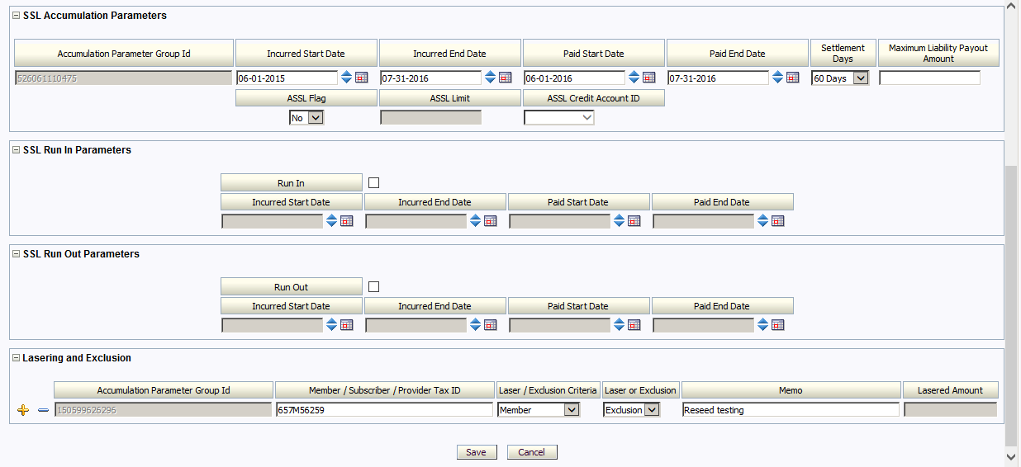

* + SSL Accumulation Parameters
    - The accumulation parameters can be found in the funding doc
    - Populate the Incurred/ Paid date ranges
    - Settlement days defines, when the final credit will be given.
    - Max payout limit defines the maximum amount that will be paid as part of the SL credit.
    - ASSL Flag is an another limit amount, categorized only at the billing group level
  + Parameters
    - Run In – Determines the other carrier transactions to be run in to Anthem for a specified period of time. Populate the Incurred and Paid date that needs to be considered for SL accumulations
    - Run Out – Determines the duration to which the transactions needs to be considered for SL accumulations. Populate the Incurred and Paid date that needs to be considered for SL accumulations
  + Lasering/ Exclusion
    - Member/Subscriber/Provider Tax Id can be excluded from the SL accumulations.
    - Similarly, a Member/Subscriber/Provider Tax Id can be lasered under a specific amount. The value for the Lasered amount is provided in the respective field.
    - Please note, the Member/Subscriber/Provider Tax Id excluded can’t be Lasered.
  + Click SAVE to complete the pricing rule setup.
  + **Aggregate Stop Loss parameters**

The first step in setting up a pricing rule is to create an ASL Pricing rule and set it parameters. Below are the steps to create an ASL Pricing Rule and the definition of its parameters.

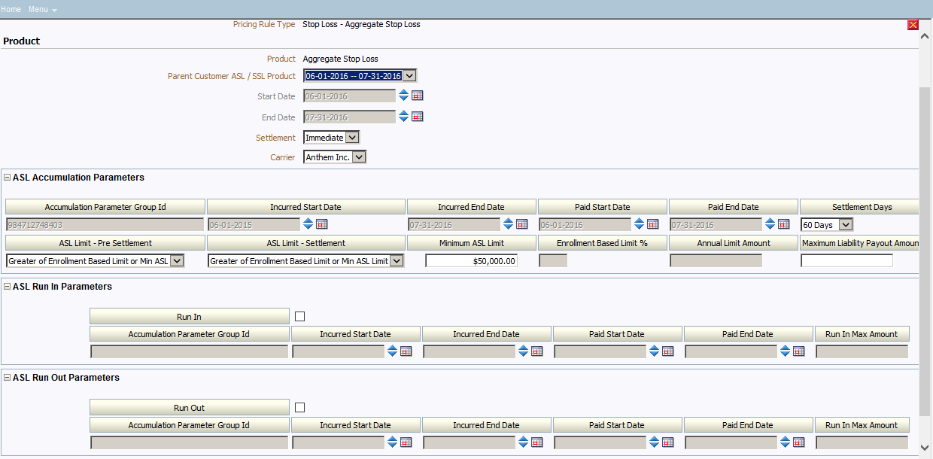

* Click Add Pricing Rule to setup the ASL pricing type
* Choose the Pricing Rule Type as Stop Loss – Aggregate Stop Loss and click Ok.
* Select the Product and choose the parent customer SSL product. This will auto input the start and end dates.
* Provide the Settlement frequency and carrier values.
* Choose the appropriate ASL accumulation parameters provided in the funding document.
* Below are the valid options for ASL Limit – Pre Settlement
  + - * % of ASL - retention based enrollment - takes the enrollment and the limit and takes the % of that
      * Annual Payment Limit – The limit provided by the underwriter. This amount is divided by 12 for every month accumulations.
      * Enrollment based limit = enrollment * the limit factor
      * Greater of Enrollment based limit or min ASL – This takes the greater value of either enrollment based limit or the min ASL value provided in the respective fields.
* Below are the valid options for ASL Limit – Settlement
* Enrollment based limit = enrollment * the limit factor.
* Greater of Enrollment based limit or min ASL – This takes the greater value of either enrollment based limit or the min ASL value provided in the respective fields.
* ASL Parameters
* Run In – Determines the other carrier transactions to be run in to Anthem for a specified period of time. Populate the Incurred and Paid date that needs to be considered for ASL accumulations.
* Run Out – Determines the duration to which the transactions needs to be considered for ASL accumulations. Populate the Incurred and Paid date that needs to be considered for ASL accumulations.
* Click SAVE to complete the pricing rule setup.
* **Stop Loss Transaction Processing**
* Overview:-Stop Loss Transaction Feed Management Process is responsible for handling transactions uploaded from RHUB, identifying the associated customer and invoicing accounts, processing the product and pricing data, and creating the consolidated billable charges for invoicing



* Process Flow: Below is the process flow for the Transaction feed processing for the SL data



* **Entity Relationship Data Model:**

Below are the list of key tables used for the SL accumulations/calculations

* CI_ACCUM_GRP - Stores the different accumulations types for the transactions.
* CI_ACCUM_GRP_SSL - Stores the various accumulations values and the characteristics for the SSL Pricing rule
* CI_ACCUM_GRP_ASL - Stores the various accumulations values and the characteristics for the ASL Pricing rule
* CI_ACCUM_GRP_SL_LASER_EXC - Stores the exclusion Member/Subscriber Id/Provider ID and the laser amount values for the Member/Subscriber/Provider
* CI_ACCUM_GRP_SL_PRICEITEM - Contains the Accum group id's and it's corresponding price item code
* CI_TXN_CALC_ACCUM_GRP - Holds the relationship between transaction calc id and accum group.
* CI_ACCUM_SSL_AMT - Holds the billable charge code for the specific member/subscriber accum group
* CI_ACCUM_ASL_AMT - Holds the billable charge code for the specific customer

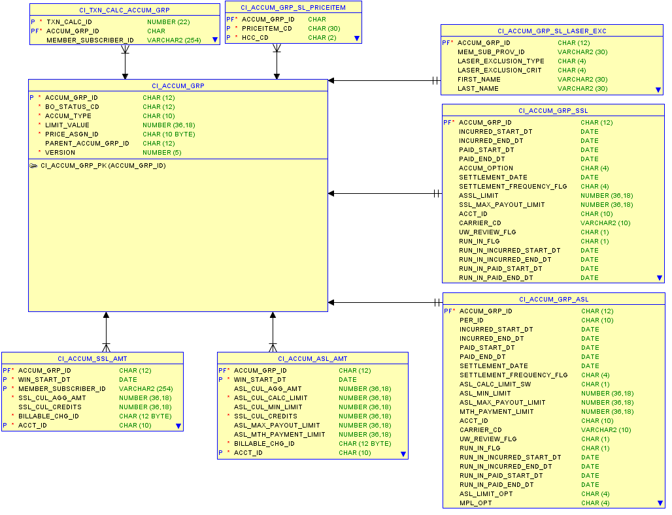

* **SSL Accumulation Process**

The SSL Accumulation Process is responsible to calculate the following and populate the SSL Accumulation Amount Table

* SSL Cumulative Aggregated Amount
* SSL limit
  + - * + Cumulative SSL Credits
* The SSL Accumulation Batch Process is executed prior to billing batch process.
* Retrieve all distinct Accumulation Group ID’s from the Transaction Calculation Accumulation table where
  + Accumulation Group ID is active
  + Accumulation Group ID is not an Exclusion Accumulation Group ID
  + Accumulation type is SSL
  + Account is eligible for billing on the batch business date
* Each Accumulation Group ID, calculate the following and populate the SSL Accumulation Amount Table.
  + - * SSL Cumulative Aggregated Amount
        + SUM all Transaction Calculation Amount by Accumulation Group ID and Member / Subscriber ID.
      * SSL Limit
        + Retrieve the SSL Limit from the Accumulation Group Table for the Accumulation Group ID
      * SSL Cumulative Credit
        + If SSL Cumulative Aggregated Amount > SSL Limit, then SSL Cumulative Credit = SSL Limit - SSL Cumulative Aggregated Amount, else SSL Cumulative Credit = 0
        + If SSL Cumulative Aggregated Amount < SSL Limit, then SSL Cumulative Credit = 0.
      * ASSL Limit
        + Retrieve the ASSL Limit from the Accumulation Group SSL table (CI_ACCUM_GRP_SSL)
        + Maximum SSL Payout Amount
* Retrieve the Maximum SSL Payout Amount from the Accumulation Group SSL table (CI_ACCUM_GRP_SSL)
* **ASL Accumulation Process**

The ASL accumulation process is responsible to calculate the following Amounts

* ASL Cumulative Aggregated Amount
* Cumulative SSL Credits
* ASL Calculated Cumulative Limit –
  + - * ASL Calculated Cumulative Limit will be calculated similar to how Retention Type – enrollment or interfaced charges are calculated. The only difference is that these products will priced only to calculate the ASL limit and will not be billed.
      * For the ASL Limits to be calculated, ORMB requires either an enrollment transaction (Enrollment or Interfaced). However, if the upstream systems are not able to send the enrollment transactions, ORMB provides a User Interface (Transaction Details) for the user to enter the counts manually. See Appendix for a sample screen shot of the Transaction Details User Interface.
* Minimum ASL Limit
  + - * Minimum ASL Computation is based on the Contract Period months and not fixed to 12 months.
      * Example –
        + ASL arrangement starts Date - 4/1/2015
        + ASL Arrangement End Date - 12/31/2015.
        + Minimum ASL Limit on Customer Setup – USD 900,000.00
        + The Minimum ASL Limit per month is 900,000.00 / 9 = 100,000.00.
* ASL Max Payout Amount
* Stop Loss Eligible Transaction Cumulative Billable Amount
* Monthly Payment Limit

The ASL Accumulation Batch Process is executed prior to billing batch process.

* Retrieve all distinct Parent Accumulation Group ID’s for all Billing Group Accumulation Group ID’s from the Transaction Calculation Accumulation table where
  + - * Billing Group Accumulation Group ID is active
      * Accumulation type is ASL
      * Account (available on the Transaction Price Item Record) eligible for billing on the batch business date
* For each unique Parent Accumulation Group ID retrieved,
  + - * Retrieve all Child Accumulation Group ID’s which are not exclusions
      * Compute the following amounts
        + ASL Cumulative Aggregated Amount
        + Sum all the transactions linked to all Child Accumulation Group ID and store it in ASL Accumulation Table.
        + Cumulative SSL Credits
        + Retrieve Parent SSL Accumulation Group ID
        + SUM all Billable Charges associated to the Parent SSL Accumulation Group ID
        + ASL Calculated Cumulative Limit
        + From the Parent Accumulation Group ID, get the Parent Person ID
        + Retrieve all accounts associated within the customer hierarchy
        + Retrieve all calculated transactions and in complete status for Product – “ASL Limit”
        + Sum all calculated transactions that fall within the ASL Price Assignment (Parent) start and end date.
        + Min ASL Limit
        + Retrieve the Minimum ASL Limit from the Accumulation Group ASL table (CI_ACCUM_GRP_ASL)
        + Get the total number of months elapsed between the month-year of the current Window Start Date from the month-year of the Start Date of the Price Assignment. Save this as the Number of Months Elapsed.
        + Compute the Minimum ASL Cumulative Limit as:
        + Minimum ASL Cumulative Limit = Minimum ASL Limit / 12 * Number of Months Elapsed
        + ASL Max Payout Limit

Retrieve the Maximum ASL Payout Amount from the Accumulation Group ASL table (CI_ACCUM_GRP_ASL)

* **Billable Charge Creation**

Below are the different steps in creating a billable charge

* Settlement frequency options available in SL during billable charge creation.
* Annual – For the annual frequency, the billable charge will be created only on the final settlement date. The final settlement period end date is the specific stop loss paid to date plus the number of days for final stop loss settlement defined in customer setup. A billable charge will be created, irrespective of whether credits need to be given to the customer or not. If no credits, then a zero dollar amount billable charge will be created. The zero dollar billable charge is created only for calculation purposes, this will not be displayed on an invoice.
* Immediate - For immediate frequency, a billable charge will be created every time, the accumulation process is executed. The accumulation process is executed every time the billing account is billed (See accumulation process for details). A billable charge will be created, irrespective of whether credits need to be given to the customer or not. If no credits, then a zero dollar amount billable charge will be created.

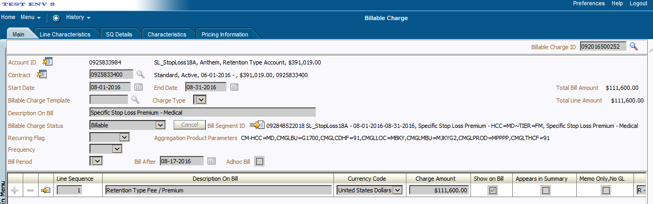

* Calculate cumulative SSL credits for the parent customer
* Calculate the billable charge amount
* Update the accumulation SSL records with billable charge id
* Complete the final settlement

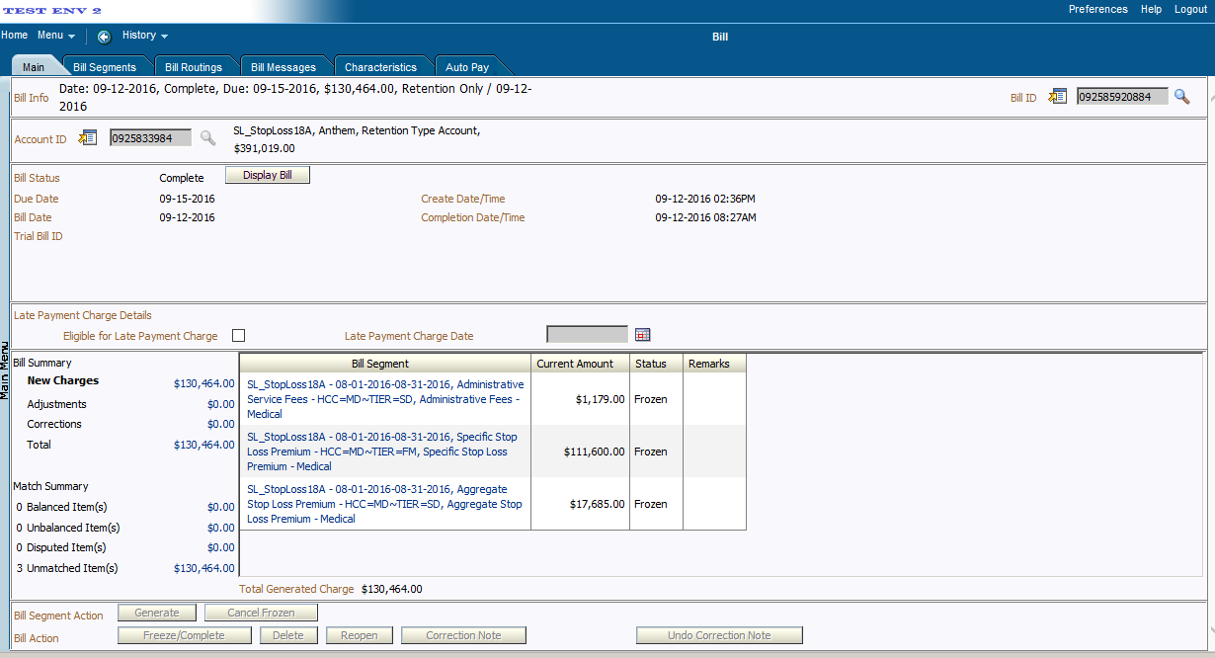

* **Stop Loss Reseeding Process**
* A Stop Loss Contract / Arrangement may be requested to be reseeded for several reasons –
* Client changes from Annual to Immediate Settlement
* Client changes from Member Level Accumulation to Subscriber Level Accumulation
* Changes to the Pricing Rules
  + - * Fee Types Eligibility
      * Domestic Provider Claims
      * Markup / Markdown
* Hence, reseeding requires
  + - * Re-pricing transactions
      * Re-calculating the Accumulation Amounts and
      * Adjusting calculated the Stop Loss Credits or Billed Amount
* Since Stop Loss Calculations work on Cumulative Amounts for the contract period, it will not be required to reset the accumulation tables. When a SL Arrangement is requested to be reseeded none of the accumulation tables, billable charges or bill segments will be reversed or deleted. Reseeding the Stop Loss Arrangement will be triggered by the TFM De-Aggregation process. A new algorithm will be called, which will be invoked by the De-Aggregation process to Reseed Stop Loss Arrangement.
* In order to reseed a Stop Loss Arrangement, the user will create a De-Aggregation request for the Account. In addition, to the de-aggregation request, the user will also flag the SSL Arrangement on the Parent Customer to be reseeded.

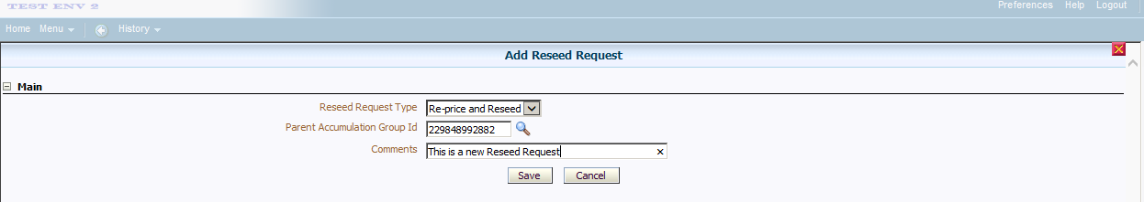

* By default, all SL Transaction Legs (Claims, EPHC, Capitation, Generics and Discount Arrangement) will be available to be de-aggregated. The algorithm will identify transactions that need to be de-aggregated for Stop Loss.
* In addition, whenever a SL arrangement is reseeded, the ASL limits will also be reseeded.
  + - * De-Aggregate all SL Transaction Legs linked to the Price Assignment
      * De-Aggregate all SL Transaction Legs linked to the Division Price Assignment
* Reseeding is a nightly process. When a SL arrangement is flagged to be receded, the nightly de-aggregation process will re-price and recalculate and re-create new Billable charges.
* Once the Billable Charges are created the biller can generate and finalize the invoice the next day.
* The SL receding process will go back to the beginning of the Stop loss Contract period and transactions will be will be de-linked and re-linked based upon new rules.
* There will no way to tie back to what was billed or on reports prior to reseeding. The updated values on the reports/invoices will tie back to the tables.
* Reseeding can be done to any SL arrangement, even SL arrangements, which have been settled.
* Below screen allows the user to verify the status of the Reseed request.

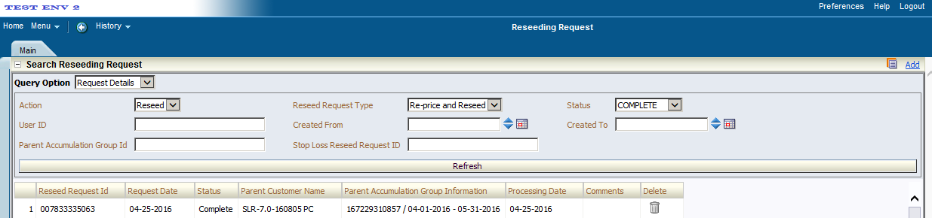

# DISCOUNT ARRANGEMENTS

* Discount Arrangements on ORMB -
* Offered to ASO customers to lower their admin fees
* Take coverage charge that the provider sends in (we negotiated with the provider a capped amount)
* Coverage amount - negotiated with provider amount
  + - * Over simplified version
      * If the outcome is negative, the discount does not get applied
* 4 types of discount arrangements (each is sold separately, except the trad discount can be combined)
  + - * Anthem is the primary payer of the claim for these discounts
      * Discounts are counted for Medical Claims ONLY
      * Based on the PAID date of the medical claim
      * Rules and criteria are on documentation

* + - * + Discount Guarantee:
        + Only applies to Facets, WGS and NASCO customers (Chips and ACES in the future release)
        + ITS and NON ITS medical claims
        + ITS (Blue Card) = another plan that is not Anthem, if a member has to go outside of the provider network

Blue cross blue shield associ. Allows the cousin plan to negotiate the fees with the Anthem

* + - * + Discount Shared:
        + % of in-network provider savings/discount
        + Institution in patient, institution out patient, professional
        + Take discount amount and calculate a %
        + Local Access Fee
        + 2 ways to bill (% of discount and PSPM)
        + Or you can have a combination of the 2 ^
        + Kind of like a different type of admin fee
        + Separate admin fee - only apply for NASCO and Facets for Nov. 2016 release
        + % discount amount

Only offered to WGS customers right now

* + - * + Like discount shared but with a much smaller network of providers
        + A lot of customers in VA, only applies to VA contract providers

Intraplan code of Y

When a provider is contracted with a different state than the customer

e.g. customers on border of Colorado, they can be contracted as a California provider and Colorado provider

* + - * + Trad Discount
        + Anthem retains a % of out of network providers
        + Provider is contracted outside of network providers
        + In certain parts of the country there may not be a lot of providers
        + Providers that don't contract with us are excluded from this
        + Totally separate report because you can sell trad discount with the other arrangements

* Discount Arrangement Pricing Rules can only be configured on the Parent Customer level.
* Discount Arrangement product will be derived by default if there is no effective Pricing Rule for a transaction being processed.
* Discount Arrangement process flow.



* Discount configuration on RMB
* Add it as a pricing rule > Discount arrangement
* Select the product
* Start and end date (same as umbrella contract dates)
* Discount arrangement screenshot below

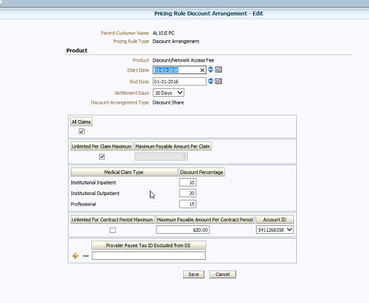

* If a DA Pricing Rule is found and has an End Date, we check if the setttlementDate is before the txnUploadDate. If not, we do not derive a DA product.
* A DA Pricing Rule is effective for a transaction, if the transactionDate is within the Pricing Rules Start and End Dates.
* We check for the validity of the Provider Type (UDF_CHAR_15) but RHUB should always give us the correct values (II, IO, or PF)
* **Derivation Truth Table:**

Discount Arrangemen

|  |  |  |  |  |  |  |  |
| --- | --- | --- | --- | --- | --- | --- | --- |
| **Discount Type/Category** | **HCC (UDF_CHAR_12)** | **COB Indicator (UDF_CHAR_22)** | **Source of Disbursement (UDF_CHAR_17)** | **Composite Transaction Field (UDF_CHAR_19)** | | | |
| **ITS FLAG** | **IN-OUT NETWORK** | **PROVIDER STATE** | **USA CLAIM FLAG** |
| Discount Guarantee | MD, MH, HT | Do not derive when value in (2, 3, 4, 20, 21, 23 or 25) | Do not derive when value is 'S' | Y or N | I | Any two digit State abbreviation or blank | Y |
| Discount Share | MD, MH, HT | Do not derive when value in (2, 3, 4, 20, 21, 23 or 25) | Do not derive when value is 'S' | Y or N | I | Any two digit State abbreviation or blank | Y  or N |
| Local Access Fee | MD, MH, HT | Do not derive when value in (2, 3, 4, 20, 21, 23 or 25) | Do not derive when value is 'S' | N | I | LNAF | Y or N |

# INTEREST CALCULATION

Interest is applied on Delinquent Invoices that are overdue for more than two days of invoice generation and open at the time of Interest calculation.

* Three type of interest is configured currently, out of which one will be selected on the Umbrella contract.
* PRIM - The interest rate applicable is (Prime interest Rate + X) %. The ‘X’ factor is captured on the Umbrella contract itself, if the Interest arrangement is ‘PRIM’
* FLAT – The interest rate applicable is flat ‘X’ % captured on the umbrella contract. The Prime Interest rate is not enquired.
* NONE – Interest is not calculated by RMB. Interest calculation and application if any is managed manually outside of ORMB.
* The interest calculation batch will evaluate each bill of the account to determine if it is eligible to accrue interest. The interest calculated for each invoice as well as the total interest calculated for the account will be captured on a case created for approval of interest.
* A To Do/ Work flow will generate monthly and notify the biller that an invoice was paid late and system calculated interest
* Biller must review prior to approving, waiving or changing interest to see if funds have been received
* Biller has the ability to:
* Approve the interest calculations
* Waive the interest calculated by reasons code
* Adjust the interest amount (if the setup was originally done incorrectly)
* Notification will be sent to the biller if there is an On account cash for the customer (future release)
* Biller has 3 days to do this, if they don't do anything within 3 days, the system will automatically approve it and bill it
* If applicable, the calculated interest amount will be displayed as ‘Late Payment charges’ on the next invoice. The supporting details for the interest (individual bills and amounts contributing to the total interest amount are available on the case CLOB and can be extracted as required). Please refer to the Bill Print extract FDD for details on Invoice presentment for Late Payment charges.
* If the biller wishes to apply only partial interest amount, the biller will move the case to ‘manual’ status. In this status also the interest adjustment will not be created. It will be responsibility of the biller to manually create the desired partial interest adjustment.
* Interest configuration steps.
* Logs into RMB
* Billing Group > set up interests at the umbrella contract level
* Edit umbrella contract
  + - * Interest will be on the main tab
        + Interest rate arrangement flag (where you select the type)
      * Interest Charge Request form
        + Interest Calculation Details
        + Keeps the history of all of the invoices and calculations
* Another way to get to the interest
  + - * Get the Account ID (under Go to Bill)
        + On the Main menu > Financial > interest charge request > put in Account ID
        + Click on the interest > Interest Charge Request Main > record actions
* Prime Interest Rate
  + - * Main Menu > Rates > Bill Factor Value > Type in Bill factor: CM
* Interest calculation batch process:
  + - * Batch frequency – Monthly (CM-INTCALC)
* **Inputs:**

Input parameters are below:

|  |  |  |  |
| --- | --- | --- | --- |
| 1 | Bill Factor for Prime interest Rate | Bill factor in which the Prime interest is stored for calculation | Bill factor in which the Prime interest is stored for calculation |
| 2 | Case Type for Waive Interest workflow | Case type defined for managing the application / waiving of interest, before adjustment is created | Case type defined for managing the application/ waiving of interest, before adjustment is created |
| 3 | To Do Type | To Do Type  (for notifying the Billing specialist about interest case) | To Do Type  (for notifying the Billing specialist about interest case) |
| 4 | To Do Role | To Do Role 1 (interest case To do) | This is the To Do Role for the To Do which will be created for Interest case |

* **Outputs:**
* Interest calculation is performed and stored on a case, if interest arrangement on the Umbrella contract is not ‘NONE’
* For each Account, Bills will be selected for Interest calculation based on following criteria
  + - * Bill is Open and has due date before or equal to Process date.
      * Bills are closed but Payment date is after Due date
* The interest calculation will be invoked for every eligible account.
* The interest calculation batch will evaluate each bill of the account to determine if it is eligible to accrue interest. The interest calculated for each invoice as well as the total interest calculated for the account will be captured on a case created for approval of interest.
* A To-do will be assigned to the Billing specialist on the account, to notify that interest case is created and needs to be auctioned. Biller can navigate to the case by clicking the To-do message hyperlink.
* The Biller can waive the interest if required, by transitioning the case to ‘Waive Interest’ status. In this status the interest adjustment will not be created. The details of waived interest are already available on the case CLOB for future reference.
* If the Biller moves the case to ‘Apply Interest’ status, an adjustment will be created for the total interest amount from case. This adjustment will be frozen when the next bill is completed for the account.
* If applicable, the calculated interest amount will be displayed as ‘Late Payment charges’ on the next invoice. The supporting details for the interest (individual bills and amounts contributing to the total interest amount are available on the case CLOB and can be extracted as required). Please refer to the Bill Print extract FDD for details on Invoice presentment for Late Payment charges.
* If the biller wishes to apply only partial interest amount, the biller will move the case to ‘manual’ status. In this status also the interest adjustment will not be created. It will be responsibility of the biller to manually create the desired partial interest adjustment.
* Case UI – Showing the actions that the biller can take and the details of calculated interest shown as case characteristics.

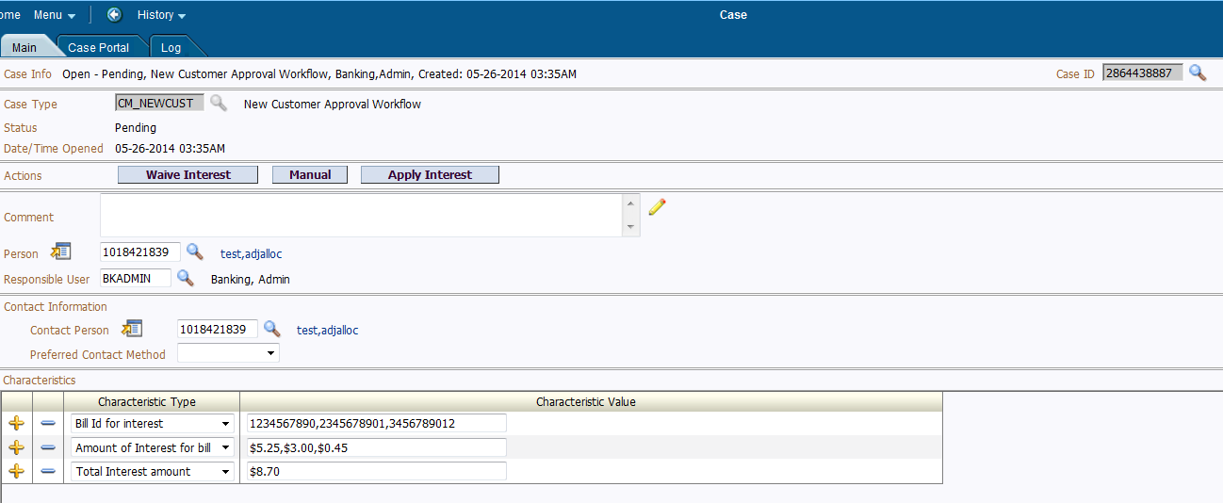

| Field / Element | Description |
| --- | --- |
| Actions | Actions that user can take to transition the case the case to next status.   * 1. Waive Interest – Interest adjustment will not be created.   2. Manual – Interest adjustment will not be created by system Biller will have to create adjustment manually.   3. Apply Interest – System will create interest adjustment and apply it to next invoice. |
| Characteristics | Bill Id for interest – Comma separated Bill ids for which interest is calculated |
| Amount of Interest by Bill – Comma separated Interest amounts for each bill |
| Total Interest amount – Total interest amount (Sum of interest by bill). Adjustment will be created for this amount. |

* When biller clicks on any action, there will be confirmation requested (pop-up) before transitioning the case to the corresponding status, to avoid transitioning by mistake. Biller will have to enter ‘Y’ to confirm the request.

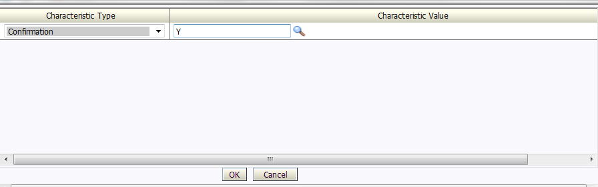

# interfaces

## EDI 820, 824/827

**Functional Overview**

The following configurations are required pre-requisites on an account for EDI820 electronic payment processing.

**Account Auto Pay Setup**

* Account Auto Pay needs to be setup during the customer setup process if setup for demand debit upfront. Otherwise, it can be setup when the customer chooses to pay using demand debit
* Account Auto Pay can be setup by accessing Goto Account Auto Pay from the context menu on the account, Account Auto Pay portal and selecting add from the portal

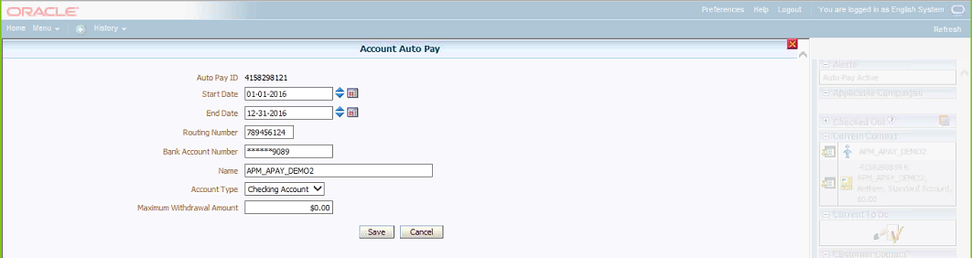

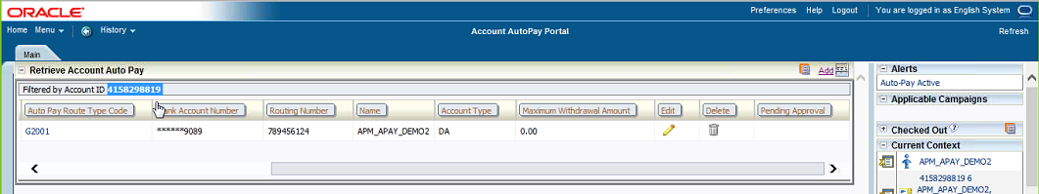

* Only one account auto pay can be effective at any given point in time
* Account autopay needs peer approval before it is saved

**Auto Pay Source Type**

* Auto Pay Source Type can be setup by accessing Admin Menu, A and Auto Pay Source Type

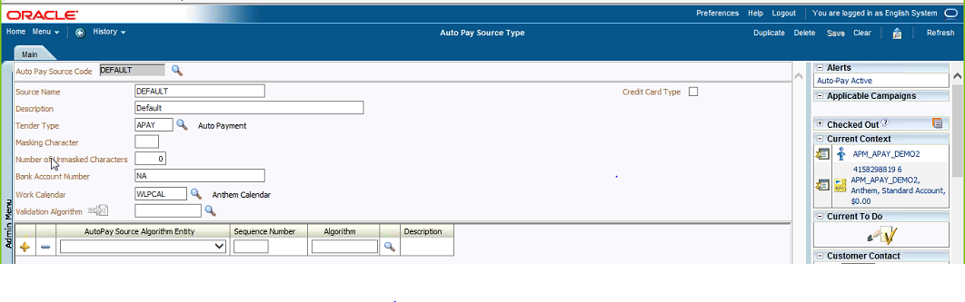

* Auto Pay Route Type can be setup by accessing Admin Menu, A and Auto Pay Route Type

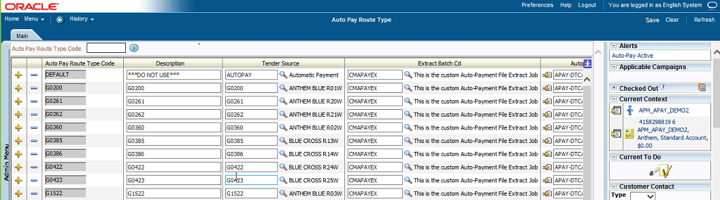

* Auto Pay Route Type needs to be set up for each legal entity. It consists of configuration for tender source. Therefore, each legal entity has its own configuration of Tender Source.

**Auto Pay Date Calculations**

* The payment terms are included in the account setup under characteristics

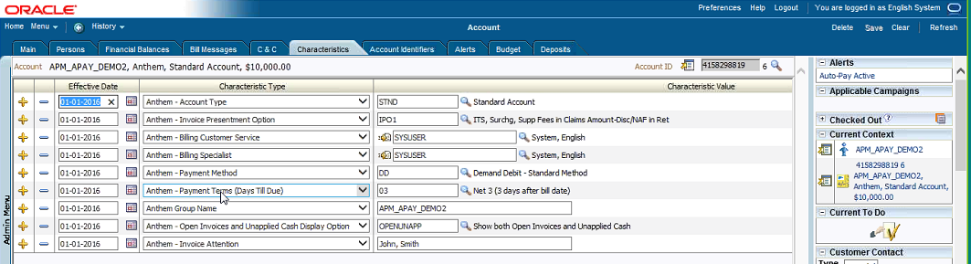

* According to Anthem – Payment Terms the bills are due on Net 3 (3 days after the bill date)
* Autopay creation date on the bill (auto pay tab) is based on this account characteristic
* The APAY-DTCALC algorithm is used to calculate the auto pay extract date based on the bill date and bill due date
* This algorithm can be accessed using Admin Menu, A and Algorithm

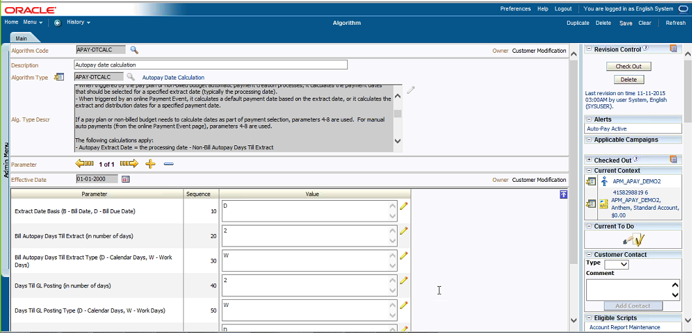

* Auto payment can be created at bill completion, on the extract date or upon Freeze Payment Notification

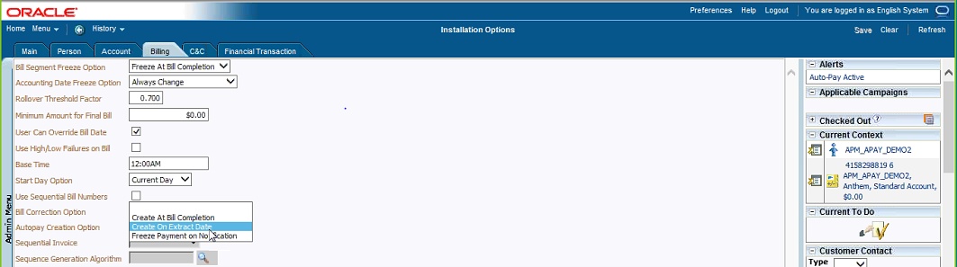

On completing the aforementioned setups, the bills that are eligible for automatic electronic payments through EDI820 are updated with Auto Pay records when they are frozen/completed

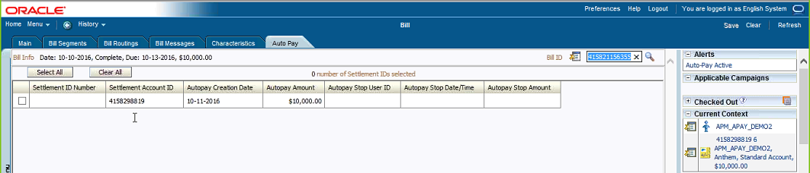

**Technical Overview**

The following batch jobs are run sequentially to process automatic electronic payments

**Batch Jobs**

* APAYCRET is the batch job that looks for all bills that have autopay setup
* ACTVTAPY is the batch job that stamps the bill for extraction with extract batch code and run#
* CMAPAYEX is the batch job used to send autopay 820 file to the financial institutions
* The financial institutions acknowledge the files sent and send a TRACE file (with a TRACE#)
* CMAPSURB is the batch job uploads the TRACE # received from the financial institutions
* Then the bank processes the 820 payment files. 824/827 file is sent back from the financial institution with the payment reject reason or details of acceptance
* CMAPYSTU is the batch job that processes the 824/827 inbound financial return file
* CMAPAYRA triggers the algorithms that payment tender information, cancel reason, NOC reason, TRACE # and also triggers the corresponding To-Do's. The following are the Auto Pay Upload Reason codes that are included in the 824/827 return file
* Auto Payment Upload Reason - Cancel, To Do Type = CM-ACH
* Auto Payment Upload Reason - Notice of Change, To Do Type = C1-ACH, Characteristic Type = CM-TRONM, CM-PYMSG, CM-NOCMS
* Auto Payment Upload Reason – TRACE
* The upload reason codes can be accessed using Main Menu, Financial, Auto Payment Clearing Staging and specifying the bill ID or account ID
* APAYDSFR is the batch that runs after CMAPAYRA and distributes and freezes payments

Admin Menu >> P >> Payment Cancel Reasons >> R__ are sent by the bank. IPE - Incorrect payment entry, OTH - any other reasons, XFER - when transferring to a suspense account

## Commissions ISGB

* The commission fee needs to be calculated by the Sales compensation system and provided to the broker. For this, RMB will be sending a file with all the billing, payment and write-off information as per the template provided by the ISGB team.
* RMB is sending both positive and the negative billing charge data in the file.
* Process Flow to generate file for Commission interface
* In case of error generated of file, a custom table created will have the ERROR status and the same will be notified to production support via email.
* Commission ISG File Creation and Movement
* Once a bill is generated in RMB and/or payment is made, this information will be written to a file and later sent to the Sales Compensation system for processing the commissions to the brokers. For this, the below steps will be performed in RMB.
* The batch process will be kicked off for generation of the Commissions ISGB file.
* Depending on the frequency of the batch process, RMB will internally check for the bills and payments for that period. For each of the distinct combinations, an entry will be written to the file. This file will then be placed in the RMB location.
* A file watcher job will also be in place, which will move the file from RMB to sales compensation system.
* Batch process details for file generation:
* CMCOMINT: This process will fetch the bill and payment information for processing and puts an entry in the CM_FT_COMM with the status as PENDING.
* CMCOMPRC: This process will fetch the bill and payment information from CM_FT_COMM with statuses PENDING and ERROR. All the other information per the ISGB template will be fetched for the corresponding bills and payments and will be written to the file

## LGCRS

* ORMB needs to be send all billed revenue over to the Large Group Client Reporting system (LGCRS).
* Currently data’s which are sent across LGCRS system are
* ASO admin fees are sent to the LGCRS application. This includes system calculated amounts and manually calculated amounts.
* ASO claim based fees taken in lieu of or in addition to enrollment based fees (e.g., %claims fees) is loaded to the LGCRS application. This includes system calculated amounts and manually calculated amounts.
* Any other fees that are not enrollment based or claims based fees, but which are considered ‘premium equivalent’ is sent to the LGCRS application. This includes system calculated amounts and manually calculated amounts.
* Information from ORMB is made available to the LGCRS application on a monthly basis, within the first 3 days of the month (this is actual days, not business days) and loaded to LGCRS by the 5th day of the month.
* Information from ORMB and loaded to LGCRS is balance to the GL and balance to comparable data loaded in Edward (another Anthem Data Warehouse receiving data from ORMB effective the ASO foundational release.)
* Process Flow to generate LGCRS file



* All billed (revenue) transactions generated in ORMB is interfaced to LGCRS via the Admin and Claim extract files. Below is a detail list of the different types of revenue transactions that is interfaced. The extracts will be driven by the list of invoices completed in the previous calendar month (on the Trigger File).
* Claims
* Retention Type Fees – Enrollment Based Admin
* Retention Type Fees – Interfaced Admin
* Retention Type Fees – Claims Based Admin
* Retention Type Fees – Non-Claim Based Admin
* PC2 – Payment Innovation
* Capitation
* Generics
* Manual Transactions
* Batch process details
* CM-LGCRSDN : This job supports the LGCRS invoice download staging process; creates a download staging record for every completed invoice in the previous calendar month that are ready to be interfaced with the LGCRS interface.
* This process populates the Outbound Message table with all completed BILL_ID s to be interfaced to the LGCRS. This process marks each staging record with the LGCRS interface’s batch process ID (defined on the Outbound Message Type). It also stamps the respective batch control's current run number on each record.
* CM-LGCRSEX: The LGCRS process creates 3 flat files that are interfaced to Anthem LGCRS Application.
* This process uses all Invoice Ids/ Batch Process records associated with its batch control that are marked with a supplied run number.

## EDWard

* Edward interface receive extract from ORMB system for every account that is billed in ORMB.
* Edward extract are compared with GL extract for balance comparison
* Edward and GL balancing happens on a monthly basis.
* Before the extracted files are FTP to Edward, Infogix does the balancing. Other balancing is done inside Edward.
* If any FTP are missed and identified during the balancing, the batch is re-run as a corrective action.
* Three data files generated as part of Edward extract:
* Billing extract: contains Account level information’s.
* Revenue extract: contains all revenue information’s.
* Claim extract: contains detailed information about the specific claim charges, at a transaction level.
* The revenue and Claim extract are incremental while the billing extract is of all accounts.
* Process Flow to generate Edward file



* Batch process details:
* CMEDWEXT: create Edward Billing setup Extract
* CMEDWDNW: create Edward download staging records
* CMRVNCLM: Edward Revenue and claim extract batch

## GL

Whenever a Bill Segment, Payment or an Adjustment is frozen there are Financial Transactions (FT’s) that are created that get included in the GL interface to PeopleSoft GL for GL posting.

* There are three types of FT’s:
* Bill Segment FT
  + - * BS
      * BX - Cancelation
* Payment FT’s
  + - * PS
      * PX - Cancelation
* Payment FT
  + - * AD
      * AX – Cancelation
* The Cancelation FT’s are created only if the frozen FT’s are cancelled. The reason is when the frozen transactions are cancelled the corresponding FT’s are not deleted, but the amounts are reversed
* Bill Segment FT’s can be accessed using Main Menu, Financial, Bill, Bill Segment and Financial Details tab, FT ID

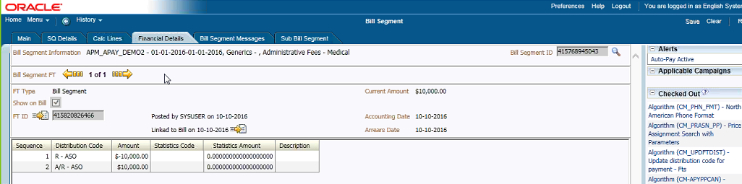

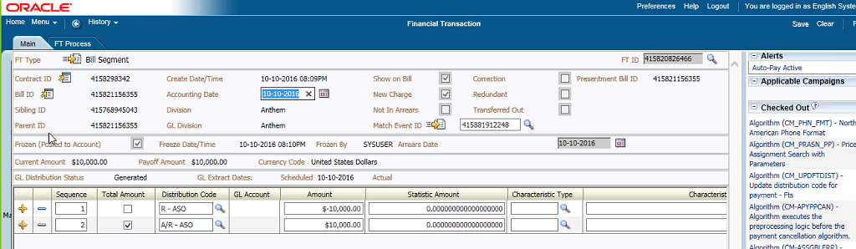

* All the FT’s in the system have FT GL entries. The number of FT GL entries depends on the number of calc lines on the bill segment. Normally there would be two entries - debit and credit
* For Bill Segments – AR is debited and Revenue is credited
* For Payments – Cash is debited and AR is credited
* For Adjustments – depending on where the adjustment is applied the FT GL entries are created
  + - * For write offs of bill segments – AR is debited and Revenue is credited
      * For actual write offs - Debit AR and credit the bad debt
* The GL distribution codes for Bill Segments on the AR side are derived from the contract’s contract type. This can be accessed using Admin Menu, C, Contract Type option and specifying the Contract Type

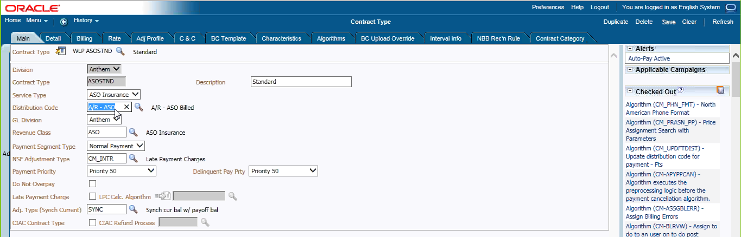

* The GL distribution codes for revenue and bad debt are derived based on the billable charge line type mapping. These can be looked up using the extendable lookup from Admin Menu, E, Extendable Lookup
* GL Strings:
* For Cash Distribution, the GL Account Algorithm GLCNST-DFLT assigns a default string to the distribution code based on the GL account defined on the distribution code table
* For AR – ASO, the custom algorithm CM-GLBUILD derives the GL string
* Once the FT's are frozen, they need to be stamped with Bill Segment ID's
* **Batch Jobs:**
* CMBSSTMP links the adjustment FT's to the bill segment FT's
* GLASSIGN batch constructs the GL strings by invoking the GL construct algorithms and stamps them against FT GL entries.
* CMRSTGL resets everything to blank if one side of the FT GL is derived and the other side is not, so that they are not included in the GL extract. Only FT GL's with well-formed strings are sent to the GL extract
* GLS goes through all FT GL’s which are not distributed and marks the FT's for extraction into the GL extract, updates scheduled distribution date and updates the distribution status to D
* CMSTATGL creates two more statistical entries. They do not have any financial impact on the system. These are used for stop loss premium transactions solely for the purpose of reporting
* CM_GLDL is a custom batch that creates GL extract according to the format provided by PSGL
  + - * There are multiple header records and detail records, Header records start with H and detail records start with L

## DMS (AP)

* ORMB identifies all overpayment amounts and initiates refund requests to the DMS (AP) system through the following flat files:
* Audit balance file and
* Detail payment file
* CM_DMEXT is a nightly process will extracts all adjustments created in the day and puts it on the extract files to DMS. This batch looks for all the accounts that have overpayments and extracts them as records. For all the overpayments amounts, in the refund adjustments created within ORMB, the AP Request tab contains the AP information needed to be extracted and sent to the DMS system

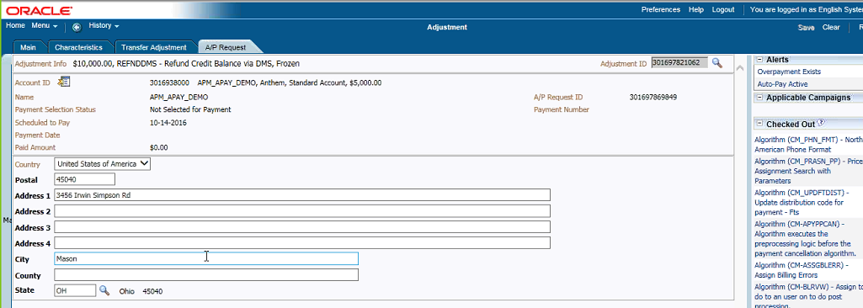

* The batch then sets a flag (PYMNT_SEL_STAT_FLG) on the accounts to “P” to indicate “paid”. This batch can be rerun only by setting off the flags from the backend. There is no front end UI to reset the flags

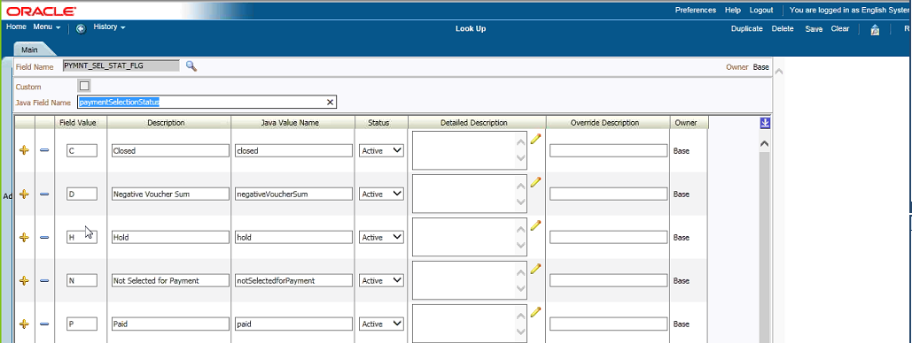

## Bill Print / Invoice Presentment

* Bill print extract is a real-time process at Anthem. It was designed as a batch process originally, but was changed to a real-time process later on.
* When a bill is finalized, several algorithms are triggered as a part of the bill completion process including post bill completion algorithms like CM_CREBPEMSG
* CM_CREBPEMSG is a bill completion algorithm that creates a bill print extract outbound message. 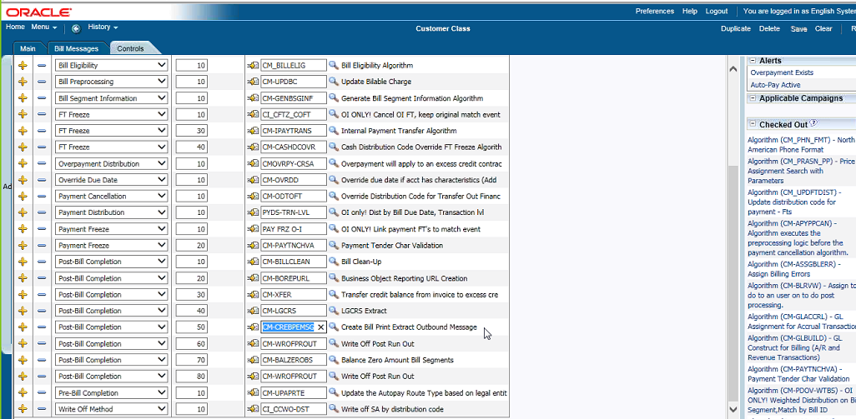

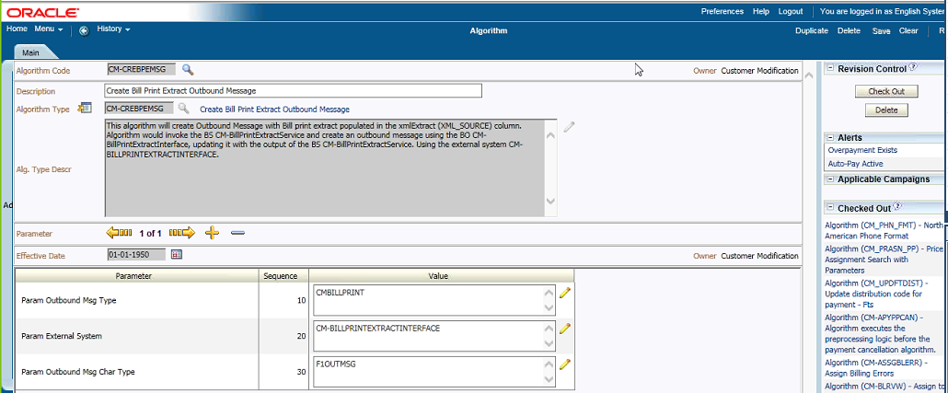

* Once the message is created, and an MPL process is kicked off to send the message to the GMS queue. Thereafter the message is marked as processed or completed
* The algorithm initiates a business service that creates an extract. This business service uses the following two views to send the data for bill print CM_BPE_PROD_INFO; CM_BPE_PROD_CATEGORY in the form of an extract to the PSD team
* PSD - Print Services and Delivery team has a process that picks up the extract and creates the PDF files
* For pending bills, there is a URL on the bill context menu called the Pending Proforma URL that lands the users on OnDemand portal. The URL has the bill ID in it. On Demand uses the bill ID to call the bill print extract service to get the extract for the pending bill.
* There are a couple of items that are not available on the pending bill
* Due date
* Completion date
* CM_EXT_SYS_DATA table contains the branding information for the umbrella contracts. If branding information is not available the bill print extract service will use the legal entity and the state code and populate the data using CM-BillPrintExtractSchema in the outbound message - CM_CREBPEMSG
* IPO - Invoice Presentment Options - The IPO’s are set on the account to determine how the billable charges are presented on the Invoices

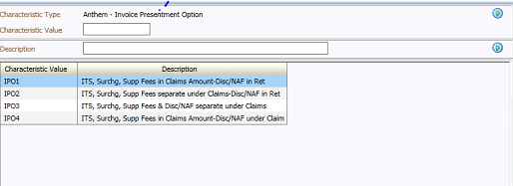

## Refund EFT

* New refund type – EFT is added to the existing auto refund process.
* RMB will be creating new refund request and track the refund and adjustment details. The same is captured in the ACH Outbound File.
* RMB will store and track all refunds (Check or EFT) and flag them.
* EFT refund payment details is written to the EDI file. The DMS process has to only process Check refund and ignore EFT refund.
* Refund EFT technical details
* Table Name : CM_REF_EFT_DTLS
* Algorithm :
* CMEFTACH - Creates the Auto Pay clearing record to be extracted in the ACH Outbound Interface
* Batch Jobs:
* CMAPAYEX –This batch is modified to include the EFT adjustments as well.
* CMAPSURB: This batch will also read TRACE-NO from the EDI file and update in CM_REF_EFT_DTLS table.
* CMAPYSTU: This batch is updated, for cancellation requested the corresponding adjustment will be cancelled along with cancel code. It also ensure it is not creating the Autopay staging upload record if the TRACE-NO received belongs to an Adjustment.
* Business Object:
* CM-CheckRefundRequest: its schema is modified by adding new tags to store account autopay details
* REFUND EFT UI: UI display all the refund details with additional account pay details. If auto pay is enabled than the values will be fetched and displayed, if not then on input map values can be entered

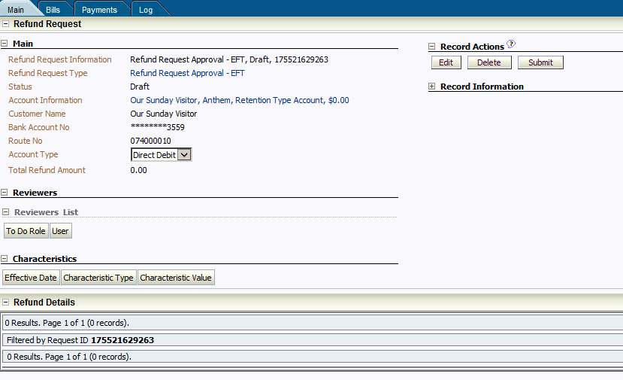

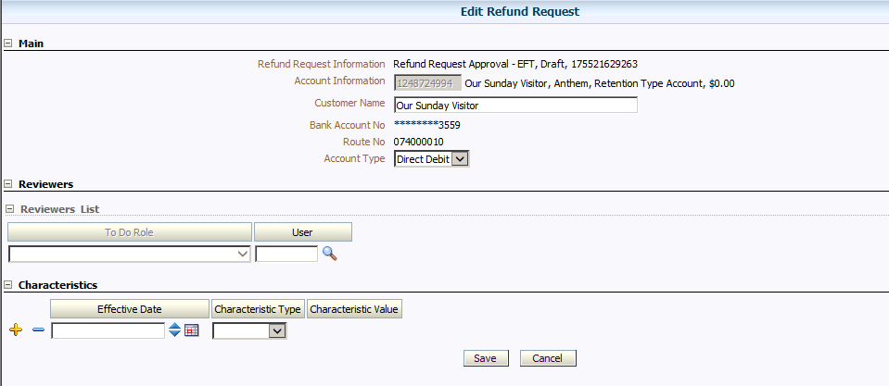

# BO Reports and Views:

## RMB External Reports:

These detailed reports are sent to On-Demand interface for the customers.

|  |  |  |
| --- | --- | --- |
| **Report Name** | **Views/Tables** | **Description** |
| Generic_Report(Ancillary_Manual_Charges) | RMBREP.RMB_EXT_RPT_INV300 RMBREP.RMB_BILL_PRINT_EXTRACT RMBREP.RMB_CUSTOMERSETUP | Used to report generic transactions which are pre-priced and Only billable generic transactions are reported. |
| ASO_Recovery_Vendor_Fee_Report | RMBREP.RMB_EXT_RPT_ASO_RCVEN_FEE RMBREP.RMB_BILL_PRINT_EXTRACT RMBREP.RMB_CUSTOMERSETUP | It contains details for different bill levels, rebates and vendor fee amounts retained for recovery. |
| Claims_Detail_Report | RMBREP.RMB_EXT_RPT_CLM0900_REIM_AMT RMBREP.RMB_BILL_PRINT_EXTRACT RMBREP.RMB_CUSTOMERSETUP | Used for reporting claim transaction in RMB which contain billable and non-billable charges. |
| Enrollment_Member_Detail_Report | RMBREP.RMB_EXT_RPT_ENROLLMENT RMBREP.RMB_BILL_PRINT_EXTRACT RMBREP.RMB_CUSTOMERSETUP | Used to report detailed member enrollments. |
| Enrollment_Subscriber_Detail_Report | RMBREP.RMB_EXT_RPT_ENROLLMENT RMBREP.RMB_BILL_PRINT_EXTRACT RMBREP.RMB_CUSTOMERSETUP | Used to report detailed subscriber enrollments. |
| Invoice_Summary_CDHP_Blended_Report | RMBREP.RMB_EXT_RPT_INV150 RMBREP.RMB_BILL_PRINT_EXTRACT RMBREP.RMB_CUSTOMERSETUP | Reports claims summary amount including CDHP |
| Invoice_Summary_Report(Excludes_CDHP) | RMBREP.RMB_EXT_RPT_INV100 RMBREP.RMB_EXT_RPT_INV300 RMBREP.RMB_BILL_PRINT_EXTRACT RMBREP.RMB_CUSTOMERSETUP | Reports claims summary amount Excluding CDHP which has data of ASO MED 20-25( ACA insurer fees, premiums) |
| Enrollment_Summary_Report | RMBREP.RMB_EXT_RPT_INV200 RMBREP.RMB_BILL_PRINT_EXTRACT RMBREP.RMB_CUSTOMERSETUP | Reports the summary of all the enrollment for the spefic time period |
| Claims_Summary_Report | RMBREP.RMB_EXT_RPT_CLM0900_REIM_AMT RMBREP.RMB_BILL_PRINT_EXTRACT RMBREP.RMB_CUSTOMERSETUP | Reports the summary of the claims for the specific period |
| Discount_Guarantee_Report | RMBREP.RMB_EXT_RPT_DIS_GUAR_PAGER RMBREP.RMB_BILL_PRINT_EXTRACT RMBREP.RMB_CUSTOMERSETUP | Reports discount guarantee which are billed along with claims |
| Discount_Share_Report | RMBREP.RMB_EXT_RPT_DISC_SHARE RMBREP.RMB_BILL_PRINT_EXTRACT RMBREP.RMB_CUSTOMERSETUP | Reports discount share which are billed along with claims |

## RMB Cash Ops Reports:

The cash ops reports are used for reconciliation, used by internal anthem team. These reports al have a standalone views in the universe.

|  |  |  |
| --- | --- | --- |
| **Report Name** | **Views/Tables Used** | **Description** |
| Daily And Monthly Cash Deposit | RMBREP.RMB_OPS_CASH_DEPOSIT | The report shows all transactions occurred monthly and daily in ORMB system |
| Unidentified_CashOps_Validation_Report | RMBREP.RMB_CASHOPS_RPT_VALIDATION | The report produces data of the unidentified queue, that includes aging of the items |

## Internal Client Reports:

These reports are used by Anthem internal team for analysis of various transactions as below, in the universe each report has a Standalone view and the trend report has a derived table.

|  |  |  |
| --- | --- | --- |
| **Report Name** | **Views/Tables Used** | **Description** |
| Annual Delinquency Report | RMBREP. RMB_INT_RPT_DELINQUENCY_ANNUAL | Produces a ondemand report on customer accounts that were delinquent at least once in their contract |
| Bill Exceptions | RMBREP. RMB_INT_BILL_EXCEPTION | Will show all the bill completion exceptions |
| Billing Timeliness for Invoice Finalization Report | RMBREP. RMB_INT_BILL_TIMELINESS | Will show when customer was to be invoiced via the schedule and the invoice finalized time. |
| Delinquency Report | RMBREP. RMB_INT_RPT_DELINQUENCY | Shows customer accounts that have unpaid balances |
| Manual Credit Report | RMBREP. RMB_INT_RPT_MANUAL_CREDIT | Shows summary on manual credit line items in RMB |
| Master DB Billing Feed | RMBREP. RMB_INT_RPT_MASTER_DB | Shows all approved customers in RMB with most recent approved contracts |
| Monthly Billing Report | RMBREP. RMB_INT_RPT_MLY_BILLING | Shows account billing activities incurred during the reporting month for all customers by business unit in RMB along with customer details |
| Self-Reporting With DD | RMBREP.RMB_INT_RPT_SELF_REPORT | Shows selreporting customers that are on autopay |
| SOX - Manual Line Items | RMBREP.RMB_INT_RPT_SOX_MANUAL | Shows list of manual items and associated TODO information in RMB |
| Trend Report | Query Defined in Universe Level | Shows all bill line items on invoice by billing line description |

## Accounting Reports:

These WEBI reports are used by the business for GL purpose and each report has separate standalone view in the universe, which has the CISADM as the source tables.

|  |  |  |
| --- | --- | --- |
| **Report Name** | **Views/Tables Used** | **Description** |
| EBS_121110_Billed_ARASO_Detail_Coverage | RMBREP. RMB_ACCT_EBS121110_DTL_COV | Produces a Detail monthly report on billed AR/ASO open items that have not been paid. For account 121110 |
| EBS_121110_Billed_ARASO_Detail_Deliquency | RMBREP. RMB_ACCT_EBS121110_DTL_DEL | Produces a Detail monthly report on billed AR/ASO open items that was delinquent. For account 121110 |
| EBS_121110_Billed_ARASO_Summary_Coverage | RMBREP. RMB_ACCT_EBS121110_SUMM_COV | Produces a Summary monthly report on billed AR/ASO open items that have not been paid. For account 121110 |
| EBS_121110_Billed_ARASO_Summary_Deliquency | RMBREP. RMB_ACCT_EBS121110_SUMM_DEL | Produces a Summary monthly report on billed AR/ASO open items that was delinquent. For account 121110 |
| EBS_121120_ASO_PC2_Unbilled_Subledger | RMBREP.RMB_ACCT_121120_PC2_TXN RMBREP.RMB_ACCT_RPT_PC2_ARASO | Produce a report on the unbilled claim transactions for PC2 received by ORMB from upstream systems for account 121120 |
| EBS_121120_Unbilled_AR_ASO_Subledger | RMBREP.RMB_ACCT_121120_ARASO_TXN RMBREP.RMB_ACCT_RPT_EBS121120 | Produce a report on the unbilled claim transactions received by ORMB from upstream systems for account 121120 |
| EBS_121170_Unbilled_Admin_Accrual_Subledger_Detail | RMBREP.RMB_ACCT_RPT_UNBIL_ADM_ACCR | Produces a detail monthly report on unbilled admin charges that were not billed by month end for groups that are not active or late renewing for account 121170 |
| EBS_121170_Unbilled_Admin_Accrual_Subledger_Summary | RMBREP. RMB_ACCT_RPT_UNBIL_ADM_ACCR | Produces a summary monthly report on unbilled admin charges that were not billed by month end for groups that are not active or late renewing for account 121170 |
| EBS_121220_Billed_ARCostPlus_Detail_Coverage | RMBREP. RMB_ACCT_EBS121220_DTL_COV | Produces a Detail monthly report on billed AR open items that have not been paid. For account 121220 |
| EBS_121220_Billed_ARCostPlus_Detail_Delinquency | RMBREP. RMB_ACCT_EBS121220_DTL_DEL | Produces a Detail monthly report on billed AR open items that are delinquent for account 121220 |
| EBS_121220_Billed_ARCostPlus_Summary_Coverage | RMBREP. RMB_ACCT_EBS121220_SUMM_COV | Produces a summary monthly report on billed AR open items that have not been paid. For account 121220 |
| EBS_121220_Billed_ARCostPlus_Summary_Delinquency | RMBREP. RMB_ACCT_EBS121220_SUMM_DEL | Produces a Summary monthly report on billed AR open items that are delinquent for account 121220 |
| EBS_121430_Unbilled_Cost_Plus_Subledger | RMBREP.RMB_ACCT_RPT_UNBILL_EBS121430 | Produces a monthly report on unbilled open items that have not been paid. |
| EBS_121430_Unbilled_PC2_Capitation_CostPlus_Subledger | RMBREP.RMB_ACCT_121430_CAP_TXN RMBREP.RMB_ACCT_121430_UNBILL_CAP | Reports on Unbilled PC2 transactions received by ORMB upstream systems |
| EBS_121460_On_Account_Cash_Subledger | RMBREP. RMB_ACCT_RPT_ON_ACCT_CASH | Reports on account cash transactions received from RMB upstream systems |
| EBS_121470_Unprocessed_Cash_Subledger | RMBREP.RMB_ACCT_RPT_EBS121470 | Generates report on unprocessed cash transactions generated in RMB due to invalid account issues |
| EBS_Daily_Banking_Report | RMBREP.RMB_ACCT_RPT_DLY_BANKING | Reports data of ACH, EFT, DD and applied cash for daily banking use. |
| EBS_Unbilled_Generic_Transactions_Subledger | RMBREP.RMB_ACCT_UNBILL_GNRS_TXN | Reports data of the Unbilled transactions which would be used in the subledger |
| Payment_Cancellation_Report | RMBREP.RMB_INT_RPT_PAYCANCEL_TRANSFER | Produces a monthly report on all the cancellation occurred in ORMB |

# Control M – ProD Batch Schedule

There are 10 **RMB** Parent Jobs (Job sets) with 29 Child jobs (Jobs) should complete by 6:00AM EST.

Daily Offshore Jobs starts at **12:15AM EST/9:45AM IST** with the Thread pool work (TPW) process.

**Note:** In case of PROD Control M job failure/delay notify Onshore, Business and take necessary action.

## RMB batch monitoring (offshore):

|  |  |  |  |
| --- | --- | --- | --- |
| **Table** | **Jobs details** | **Schedule (EST)** | **Description** |
| **Job Set 1** | **RMBAPP_PRD_TPW_PROCESS** | **12:15 am ET** |  |
|  | RMBAPP_TPW_RESTART1 | 12:15 am ET | Threadpoolworker Restart On Server mom9p10041 |
|  | RMBAPP_TPW_RESTART2 | 12:20 am ET | Threadpoolworker  Restart On Server mom9p10042 |
| **Job Set 2** | **RMBAPP_PRD_TFM_DISAGREEGATION** | **12:30 am ET** |  |
|  | RMBAPP_IDENTIFY_AFFCT_TRANS | 12:30 am ET | Identify Affected Transactions |
|  | RMBAPP_PROCESS_NON_AGG_TRANS |  | Process Non Aggregated Transactions |
|  | RMBAPP_DEAGG_CLEANUP |  | DeAgg Clean Up |
|  | RMBAPP_UPDATE_DEAGG_REQUEST_STATUS |  | Update Disaggregation Request Status |
|  | RMBAPP_DISC_ARR_DEAGG |  | Disaggregation of Discount Arrangement |
| **Job Set 3** | **RMBAPP_PRD_TFM_AGREEGATION** | **12:30 am ET** |  |
|  | RMBAPP_ROLLBACK | 12:30 am ET | Rollback of error transactions |
|  | RMBAPP_FLUSH_CACHE |  | Test RMB Control M Job F1_FLUSH - refresh cache |
|  | RMBAPP_HEADER_VALIDATION |  | Header Validation |
|  | RMBAPP_VALIDATE_PRODUCT_ASSIGN |  | Transaction Validation and Initial Product Determination |
|  | RMBAPP_PRODUCT_PRICING_VERFY |  | Product Pricing Verification |
|  | RMBAPP_UPDATE_STATUS |  | Update Status |
|  | RMBAPP_RATING_BATCH_PRODUCTIZED |  | Daily Rating Productized Version |
|  | RMBAPP_MARK_COMPLETION |  | Mark Completion |
|  | RMBAPP_AGG_CLEANUP |  | Clean Up Agg Process |
| **Job Set 4** | **RMBAPP_PRD_DISC_ARR** |  |  |
|  | RMBAPP_ACCUM_DISC_ARR |  | Accumulate Discount Arrangement |
|  | RMBAPP_CREATE_BILL_CHG_DISC |  | Create Billable Charge for Discount |
| **Job Set 5** | **RMBAPP_PRD_CSADM_UPD** | **12:30 am ET** |  |
|  | RMBAPP_CISADM_STAT_UPD |  | TPW CISADM STAT update |
| **Job Set 6** | **RMBAPP_PRD_DB_STUPD** | **12:30 am ET** |  |
|  | RMBREP_REP_STAT_UPD |  | TPW RMBREP STAT update |
|  | RMBHUB_HUB_STAT_UPD |  | TPW RMBHUB STAT update |
| **Job Set 7** | **RMBAPP_PRD_COLLECTIONS** |  |  |
|  | RMBAPP_PROMISE_TO_PAY_MONITOR |  | Promise To Pay Monitor |
|  | RMBAPP_COLLECTIONS_OVERDUE_MONITOR |  | Overdue Monitor |
|  | RMBAPP_COLLECTIONS_OVERDUE_CUTEVENT |  | Overdue and Cut Event Manage |
| **Job Set 8** | **RMBAPP_PRD_BILLING** | **01:00 am ET** |  |
|  | RMBAPP_ACTIVATE_CONTRACTS | 01:00 am ET | Activate pending start/stop Contracts. Each initial (new and approval case workflow) customer has pending contracts created and then changes to active in this process. Transactions not billed until contract is active. |
|  | RMBAPP_CREATE_BILLS |  | Create Bills (Proforma Invoice) for Billable charges broken out by Bill Segments.  **Marks completion of RMB Billing cycle (Pending Bill Finalization) |
|  | RMBAPP_WRITEOFF_ADJ_SRA_CUST |  | Create Write-off adjustment for SRA customers |
| **Job Set 9** | **RMBAPP_PRD_EDWRPT_MV** |  |  |
|  | RMBREP_EDW_RPT_MV |  | Refresh Edward Materialized View. |
| **Job Set 10** | **RMBREP_PRD_DLY** |  |  |
|  | ORMB_DLY_PEND_DOC |  | ORMB Pending Doc - Create External Preliminary Invoices and Reports |

## Detailed Batch Jobs:

120 Batch Jobs were schedule Daily/Monthly/Adhoc

Attached the consolidated the detailed document.



# Reference Documents

| Subject Area | Link |
| --- | --- |
| Application Support Control Plan (ASCP) | [Click here](https://wgsmodernization.atlassian.net/wiki/download/attachments/45875281/ORMB_Application_ASCP_20161026_v1.docx?api=v2) |
| TDD | [Click here](https://wgsmodernization.atlassian.net/wiki/download/attachments/23658583/TDD_ASO_Billing_Replacement_and__Migration_V2.0.docx?api=v2) |
| Architecture Diagram | [Click here](https://wgsmodernization.atlassian.net/wiki/download/attachments/23658583/Context%20Diagram%20-ORMB.pdf?api=v2) |
| TFM Process | [Click here](https://collaborate.wellpoint.com/sites/BillingASO/Plan%20Execute/Release%20and%20Deployment%20Docs/Oracle%20Software%20Configuration%20Management%20Documents/Oracle_Revenue_Management_and_Billing_Transaction_Feed_Management_-_Batch_Execution_Guide.pdf) |